WALT: understand what makes me feel worried w/c 21.3.22

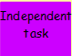
My Worry Monster
My monster name:
My worry monster looks like:
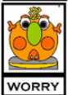
Write about when your worry monster arrives. What makes you feel worried? What helps you get back to your upstairs brain?

