

Circle a quarter of the bread.

Thomas Farriner has asked his workers to put a quarter of the loaves he’s baked in the over.

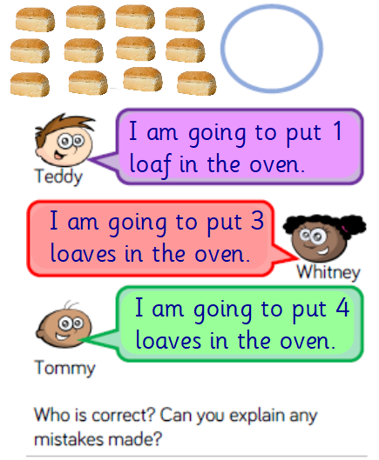

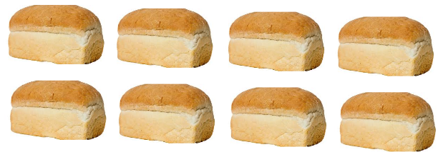

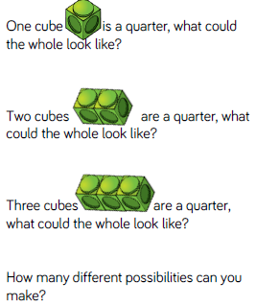

Who do you agree with?

Explain why.

How many different possibilities can you make?

Use cubes to help you then record in your book -

If ___ is a quarter ___ is the whole.