Summer Term 1: Week 4
Sports Challenge
Dancing Shoes at the Ready!
On Friday 8th May we celebrated the 75th anniversary of VE Day. During the time of the Second World War, swing dancing was a very popular style of dance and many will have taken to the streets to celebrate by having a dance with friends and family!
So today we are going to celebrate VE Day by learning a popular swing dance of the era – The Jitterbug! The music is Glenn Miller’s ‘In the Mood’.
Watch the video of Mrs Machin and Miss Mather and see if you can learn all of the moves.
When you have learnt the whole dance, create 4 moves of your own (in the same style) to add onto the end!
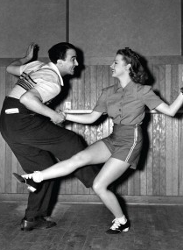
Make sure you send in videos of yourselves – we’d LOVE to see your super moves!
