Summer Term 1: Week 3
Maths Activity 4 – Multiplication and Division

Task 1 -Warm your brain up!
Answer these calculation questions as quickly as you can. Can you answer find the answers mentally, without using your fingers or drawing?
2 x 3 = | 10 ÷ 2 = | 4 x 10 = | 2 ÷ 1 =
20 ÷ 5 = | 5 x 2 = | 25 ÷ 5 = | 6 x 2 =
10 x 3 | 30 ÷ 10 = | 7 x 5 = | 10 ÷ 2 =
15 ÷ 5 = | 7 x 2 = | 8 ÷ 2 | 8 x 5 =
10 x 2 = | 30 ÷ 5 = | 2 x 4 = | 18 ÷ 2 =
70 ÷ 10 = | 9 x 5 = | 10 ÷ 5 = | 8 x 10 =
8 x 2 = | 45 ÷ 5 = | 5 x 5 = | 100 ÷ 10 =
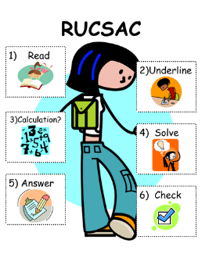
Task 2
Can you solve the word problems using RUCSAC to help you? Remember to use all of the calculation strategies to help you to solve the equations, and check your answers carefully!
Joe makes 80 cakes. They need to be put into boxes. Each box holds 5 cakes. How many boxes will Joe need? | Phil collects Pokémon cards. There are 10 in a packet. He buys 2 packets. How many Pokémon cards does he have altogether?
There are 9 children at a party. Each child eats 2 sweets. How many sweets are eaten altogether? | Claire makes 5 trays of cakes. There are 7 cakes on each tray. How many cakes does she make altogether?
James and Alfie have been to the shop and have bought 10 sweets to share between them. How many sweets do they get each? | Miss Shaw shared 39 stickers equally with 10 children. How many did the children get each? How many were left over?
Lucy has 5 packets of felt tips. Each packet holds 10 crayons. She has to share them between 5 tables. How many felt tips will each table get? | There are 35 chairs left over in the hall after an activity. They get stacked into piles of 5. How many stacks of chairs will there be when they are all put away?

