Summer Term 1 Week 4
Engage
English Task 4: Writing your own adventure story
Can you use what you remember from Task 2 to add the correct end punctuation to these sentences?
Choose from:
.
!
?
- What a beautiful day is it
- How many socks do you have
- When will dinner be ready
- The boy jumped up out of his bed because it was his birthday

Challenge: Add in two missing pieces of punctuation.
Think about the punctuation we may need in the middle of a sentence, or if there are two separate sentences.
I love to go walking running and cycling in the hot sunshine
Today I am going for a walk in the park so I will need to put my trainers on
I would like to eat some fruit today do you prefer apples or oranges

Independent

Write an adventure story about what your toy might get up to during the day when no one is around (like Toy Story).
- Describe your character’s appearance
- Describe where they live
- Describe their personality
- What adventures do they go on?
- Do they have any friends?
- Remember the sequence of a story:
Beginning Build Up Problem Resolution Ending

See my example on the next page!

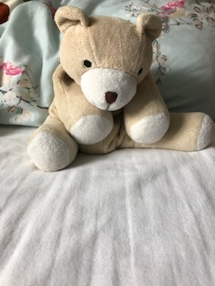
This is Crinkles…

The Adventures of Crinkles the Cuddly, Cunning Bear

Beginning
This is a story about a bear called Crinkles. He had sandy coloured fur, a big white nose and was very soft. He was filled with beads which made a crinkling sound when he moved! Crinkles loved to go on adventures, but he could only escape when there were no humans around. He had to be very careful when he moved, so no one would hear or spot him. Crinkles was a sneaky bear, and he was always playing funny tricks on his friend Stevie the Eevee. Their owner did not know that they could talk, and they would always wait until she was out of the room before they would continue their wild adventures. One day, Crinkles wanted to explore outside in the garden, but he had to go all the way downstairs without being found!

How will he do it?
What will he find?
Will Stevie help him? Or will he explore on his own?
You can continue writing the rest of my story or make your own with your favourite toy. I have used the past tense.
You can write or type it. Send it to your teacher so they can read your brilliant stories.
My email address is: minorsb@dobcroft-inf.sheffield.sch.uk
Your teacher’s email address in on your class page on the website.
Tick the SPaG features that you have included.

