Summer Term 1: Week 4
Reading Challenge
What’s your favourite book?
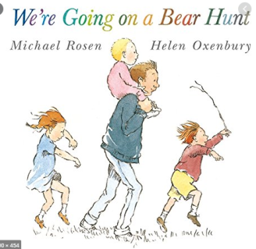
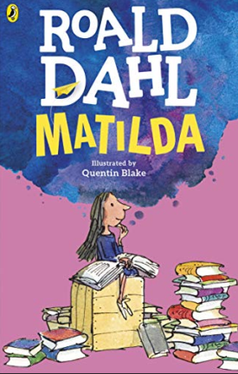
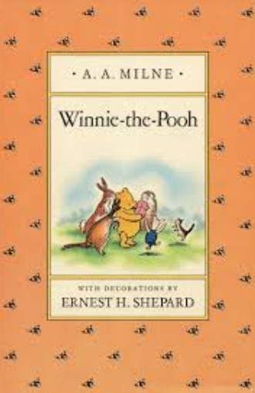
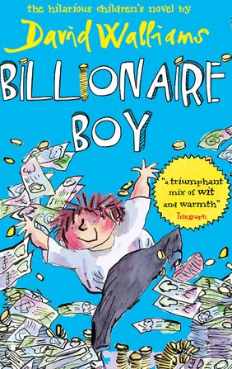
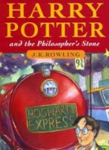

There are so many books to choose from aren’t there! These are just a few of our favourite stories but we know you will have thought of loads more!
Now decide on your favourite book that you have at home and read it again! Once you’ve read it, have a go at the activity below.

Close your eyes and think about the story.
What happens? What characters are there? Which is your favourite part? How does it end?

Open your eyes.
You are now going to create your own ending to your favourite story – and you can be as creative and inventive as you like! Perhaps think about what might happen differently if an event in your story doesn’t take place. Or what would happen if a certain character did or didn’t do something? How would the ending of the story change?
Perhaps start by writing all your ideas down in notes on a piece of paper. You can then decide what you’d like to include and begin re-writing the end of the story.

