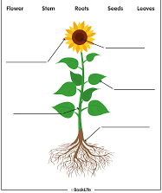
WALT - To identify the parts and functions of a flowering plant.
Success Criteria:
- I can identify, draw and label the parts of a plant.
- I can write sentences identifying the functions of a plant.
Deepen- I can find out and describe how plants need water, light and a suitable temperature to grow and stay healthy.
Challenge – Have a look on Purple Mash and have a go at some of the 2Do’s you have been set!

