Hello Everyone!
We hope you have had a good week!
This week it rained and I went out into the garden and took some photos of bees and raindrops.
Here are the photos I took.
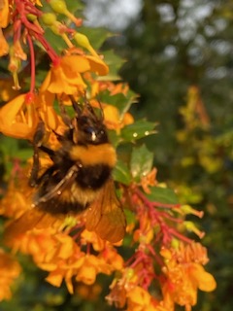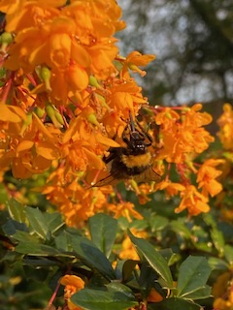
Can you see this bumble bee’s tongue?
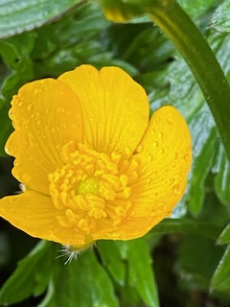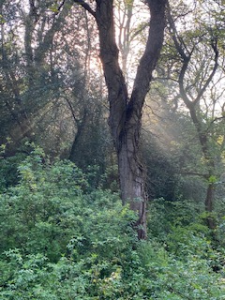
This tiny buttercup had droplets of water inside the petals! Can you see the sun’s rays coming through the trees?
This week Mrs Burgan made shortbread. It was sweet and buttery and crunchy.
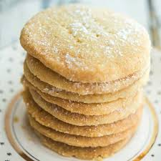
Here is the recipe if you want to try:
https://www.bbc.co.uk/food/recipes/shortbread_1290
Have a great week and send us photos if you get a chance!
We miss you!
The Foundation Stage Team.

