Summer Term 1 Week 3:
Reading Task: Find adjectives and synonyms
Hi Year Two! Miss Minors has been enjoying reading lots of books in the sunshine! I wonder what books you have been reading or listening to?
Today I would like you to read your favourite book.
Draw your favourite character in the box below.

Find 3 adjectives or phrases that describe:
- Their appearance (circle in red)
- Their personality (circle in green)
Write the adjectives around the box.
(If it doesn’t tell you in the text, write down what you think they look like, their personality and how they would feel.)
Now find synonyms for the adjectives, write them underneath the word or phrase and underline them.

Book title: __________________________________________________________________

Character’s name: ___________________________________________________________

CHALLENGE: Ask an adult to pick 3 events in the book for you. See if you can put them in the right order!
My Example: (I have underlined the synonyms underneath each word or phrase).

Book title: Matilda

Character’s name: Miss Honey
Slim and fragile
Light brown hair
Delicate
Mousy brown hair

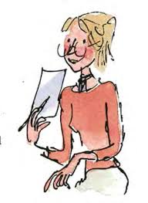

Sad

Glum

Gentle
Mild
Peaceful
Calm
Blue eyes
Ocean blue eyes

