Summer Term 1: Week 3
English Task: 4
Can you write a spring setting description? It could be a spring garden, forest, meadow – wherever you like! Can you read it out to a relative over the phone? Tell them to close their eyes and see if they can imagine the beautiful setting you have described in your writing.
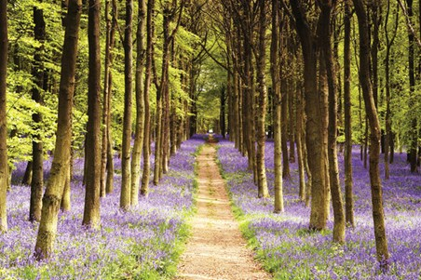
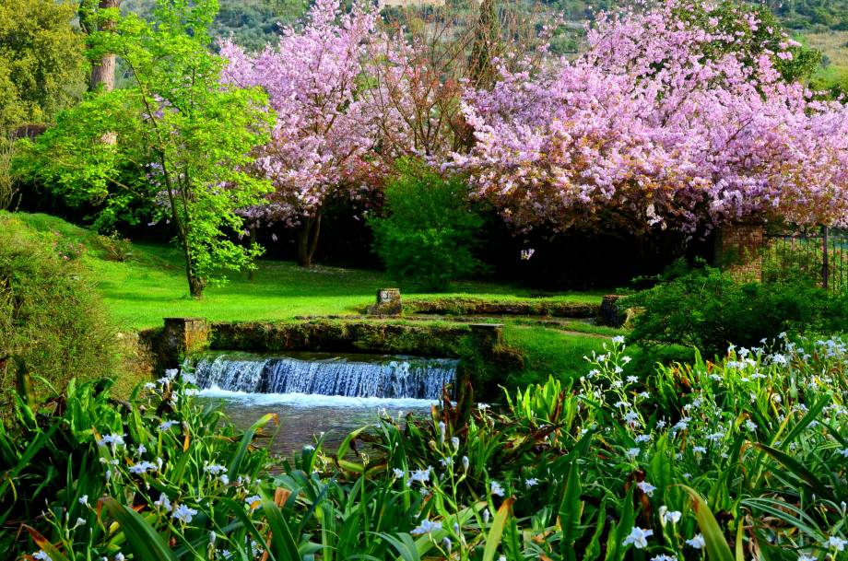

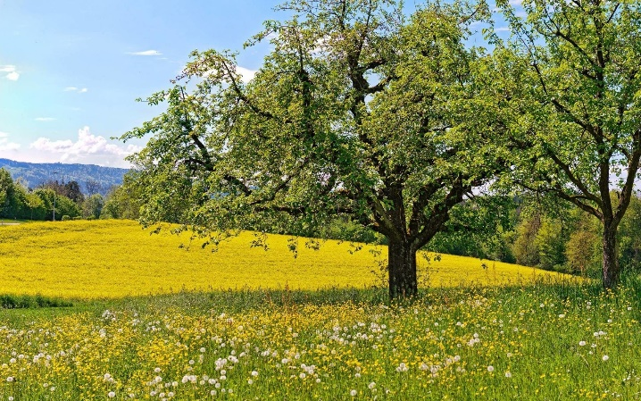

Top Tips:
- Remember to include what you think you can see, hear, feel, touch and smell. (Your word bank can help you with this)
- Include exciting expanded noun phrases.
- Start your setting description with an interesting opener.
- Remember to include conjunctions – and, but, so, when, as, if

Here’s the beginning of the setting description Miss Culshaw wrote for you all
When I carefully stepped into the beautiful garden, the smell of blooming flowers wafted up into my nostrils. I felt like I was floating on air! The freshly cut blades of grass tickled my toes as I took another step into the glorious garden. All around me there were tall trees covered in bright pink blossom, and I could hear birds quietly tweeting above me. What a wonderful sound!

