Summer Term 1: Week 3 w/c 27.4.20
English Task – Describing a setting

For your English task today, you are going to describe a setting. Have a look at the different settings below, and choose your favourite one to describe.
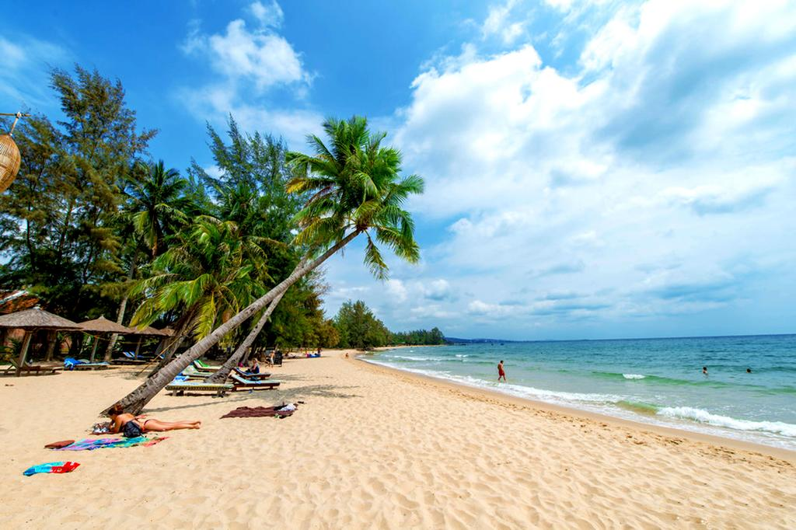
When you are describing, think about the following:
- What can you see?
- What animals would live there?
- What would you be able to smell?
- What would you be able to hear?
- What would the temperature be?
- Who would live there?
- What food would you eat there?
- What activities could you do there?

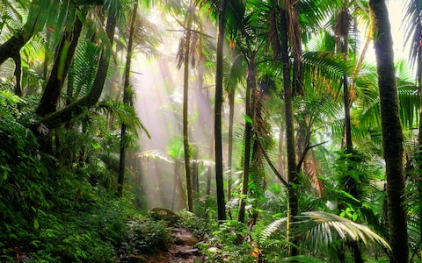
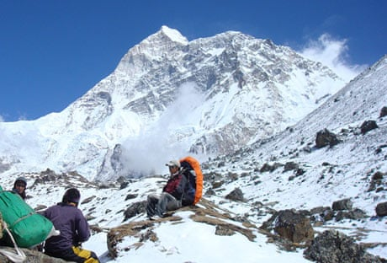
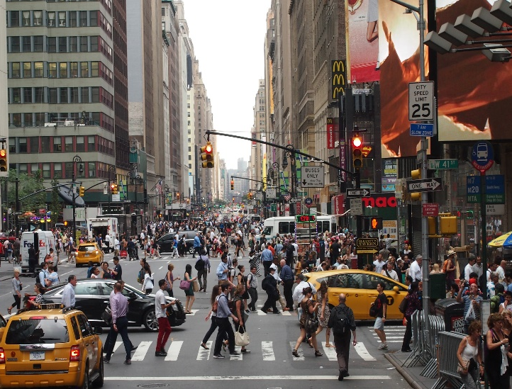

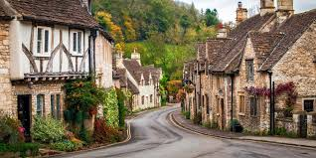

Challenge: Can you describe another one of these settings? Could you read it to a family member and ask them to guess which setting you’re describing?

