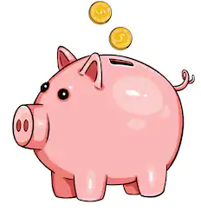
Summer Term 1: Week 3
Maths Activity 1 – Money (Recognising coins)

Today we are going to be thinking about money! Even though we can’t get to the shops as easily at the moment to spend our pennies, we can still practise around the house.

Task 1
Look around your house (make sure you ask a grown up) for as many different coins as you can find.

Can you group them into the same types of coin? Can you order them from the smallest amount to the largest amount?

Look at how each coin is different (shape / size / colour) – how does that help you recognise what each coin is? You can write your ideas below!
REMEMBER! Some coins are in ‘pence’ and some coins are in ‘pounds’. Do you know which is which? What signs do we use for each one?

Challenge: Count up all the coins that you have found to work out how much money you have altogether! What do you think you could buy with this amount of money?
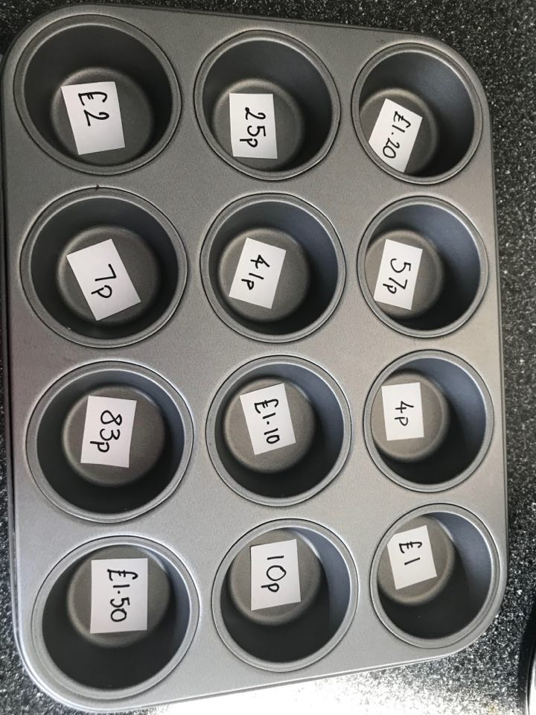

Task 2
Miss Mather has had a lot of fun at home making this coin counting game using a muffin tin. Can you make something similar at home?

Choose your own amounts to write into each tin, and then place the correct number of coins into each hole to make the right amount.

(If you don’t have enough coins, why not make your own)!

