Summer Term 1: Week 2
Reading Task
Hi Year 2! I hope you have been reading lots of fantastic books! Read a book of your choice, then complete this game with someone at home! All you need is a dice and a book! Roll a number then answer the question, happy reading!
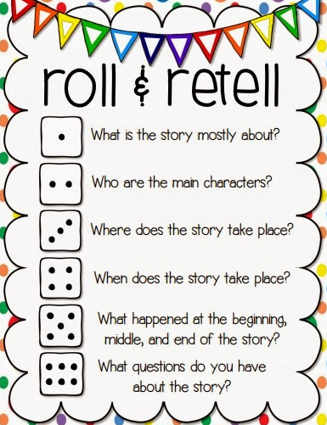

For an extra challenge, can you think of your own questions that you could ask about the book? See if someone at home can answer them!

