Art task - sketching flowers
Practise your sketching skills this week whilst getting out into your garden.
As a warm up, shade these leaves using a sharp pencil. Shade the first leaf as light as you can, then shade each leaf with more pencil pressure (making it darker) until you shade the last leaf as dark as you can.
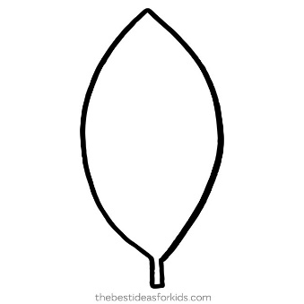

dark
light

Now can you have a go at sketching some of the flowers in your garden? Change your pencil pressure from light to dark to create tone in your sketch.
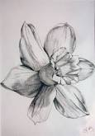
Challenge - can you use shading to show the parts of the flower that are in the light and those that are darker?

