Summer Term 1: Week 2 22.4.20
English Task 3

Have a think about what your favourite things about spring are? Miss Mather loves the daffodils growing in her garden, the blossom on the trees and the lighter evenings. Her favourite thing about spring however is...THE ANIMALS! There are so many cute baby animals that are born in the spring!
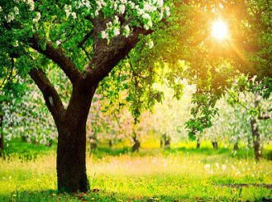
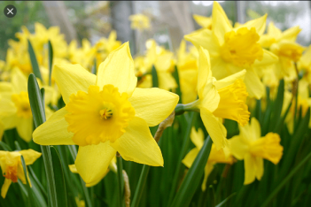
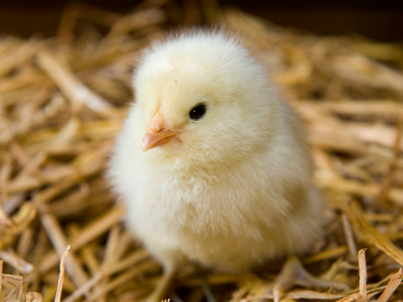
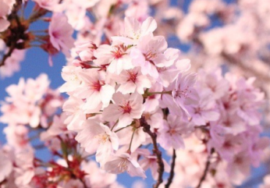

- Miss Mather was wondering if you could help her out by making a list of animals that are born in the spring. How many can you think of? Are there more than 10?

- When you have written your list, choose just one animal (maybe your favourite) that you are going to focus on today. Write some question sentences that you would like to find out about your animal.

- Then grab a book or ipad and see how many you can answer. Make sure you write down everything that you find out – these facts might be useful for a fact file about spring animals!

Use the ideas below to help you get started with your fact finding questions!
Name?
Diet?
Habitat?
Appearance?

