Summer Term 1: Week 2 21.4.20
English Task 2

All of the teachers have been spending lots of time reading some of their favourite stories lately. Have you been doing lots of reading too?

Take a look at the characters below from some of Miss Mather’s favourite books. Choose just one and write a character description about them.

Use these questions to help you with your description.
- What do they look like?
- What do they wear?
- What is their job?
- What story are they from? (If you know!)
- What is their personality like? Are they a good character or an evil character?
- What are their hopes and dreams?

When you have finished, read your character description to another family member, and see if they can guess which character you are describing!
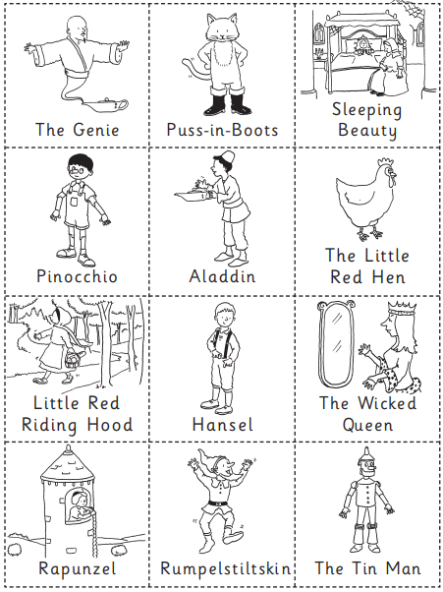
Did they guess correctly? Why not pick another character and try again!

