The Music Curriculum

Our vision
At Dobcroft Infant school we believe that music is an essential part of everyday life, and is a way to express ourselves, our emotions and our ideas. Music encourages children to learn about different instruments, composers and the effect they are trying to convey either in their instrumental music or in their lyrics. At Dobcroft Infant School we want children to become musicians both as individuals and as part of an ensemble. We use music throughout the school day at transition points such as when children enter a classroom, at lunchtime in our dining hall and across the majority of lessons including maths and geography for example. Music should also be accessible for all, so we have learnt a number of songs in Makaton, with some of our SEN pupils being able to teach their classmates the actions.
In our Foundation Stage 2, music planning follows the Early Years Foundation Stage guidance as part of the Expressive Arts and Design: exploring and using media and materials area of learning. In KS1, we follow the learning objectives as set out in the National Curriculum. We hold weekly Singing Assemblies where children learn about composers and music from a range of ethnicities and cultures as well as learn chants and sing songs in time to a beat with correct tune, enunciation and enthusiasm. These songs are often linked to our PSHE or year group theme. Each year group also hold a performance each year – Foundation Stage 2 and Year 1 at the end of the Autumn term and Year 2 at the end of the Summer term.

How is music taught at Dobcroft Infant School?
We have recently invested in the Charanga Scheme of Work for Music and this includes guidance for the Foundation Stage. The scheme is based on National Curriculum expectations and comprises of 6 units of work for each year group with clearly defined learning objectives. The Foundation Stage 2 are trialling this scheme currently and we will be rolling it out into Key Stage One. Music in Key Stage One is taught using the Kodaly approach to music. In the academic year of 2018/19 we took part in a research trial of a new scheme of learning using chants and songs from the Kodaly music approach called FirstThing Music and have adapted planning in Key Stage One to include songs from this resource bank so pupils are learning songs in an accessible pitch as well as learning about beat, rhythm and pitch. Our outdoor provision also supports children’s exploration as we have music stations in the playground with different percussion instruments so children can compose, listen or sing along with their friends.
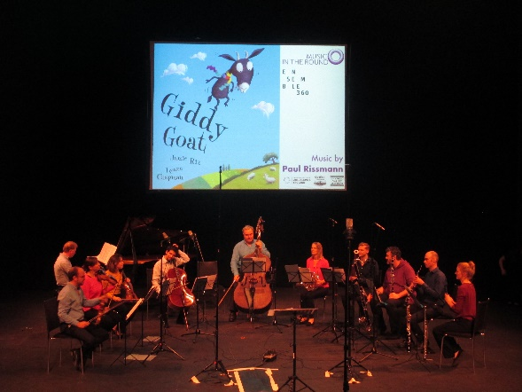
We believe it is important for children to see music in action, so each year we participate in the Music In The Round event at the Crucible Theatre. We take the whole school along to hear the different orchestral instruments played live and join in with singing in a real auditorium. Each year different teachers go along to the training to upskill themselves and then in turn teach the songs and actions to their year group. In previous years we have also participated in Sheffield Music Hub’s Key Stage 1 Singing Festival at Sheffield Cathedral, a Spring of Singing concert in collaboration with 3 schools in the local area and our annual Carol Concert at Holy Trinity Church. We also work closely with Sheffield Music Hub, hold the ‘Sing Up’ gold award and became a Music Mark member for recognition of our willingness to improve music provision, the high value we place on music education and for providing music opportunities for all children.

Foundation Stage 2
At this area of development, pupils will be building up a repertoire of songs, tap out simple, repeated rhythms and explore the different sounds of instruments. Staff are guided by the children’s own interests alongside nursery rhymes and songs linked to their topic at the time and are also guided by the Musical Development Matters document that was published in September 2018. In the Foundation Stage they have untuned percussion instruments in the continuous provision so children can access these throughout the day, and they also have access to the 2Simple Compose programme on the classroom computers to record their music with an adult.
Key Stage One
In Key Stage One, each year group has a bank of untuned percussion instruments also so they can compose and explore music in music lessons.
In Year One pupils explore these different untuned instruments and learn new musical vocabulary such as beat, rhythm and pitch. They create pieces for a purpose and change one of these elements to explore how they affects the listener. They begin leading songs, taking on solos or small group performances to build confidence. Pupils listen to a range of music to begin discussion about emotions and feelings we experience when listening to music.
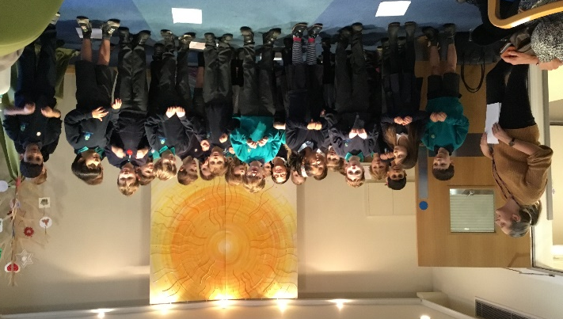
In Year Two, children build on their knowledge of key vocabulary by also including dynamics (piano and forte) and tempo. Alongside their music lessons, each pupil in Year 2 also has 16 weeks of violin lessons provided by a peripatetic music teacher from Sheffield Music Hub on a Wednesday afternoon for 45 minutes. Year 2 pupils also go out into our local community to perform Christmas carols at St Luke’s Hospice and Ranulf Court.

How can you help at home?
- Listen to a wide range of music around your house
- Talk to your child about your favourite music, musicians, film scores etc
- Practise tapping beats out for your child to copy – can they do the beat and you do the rhythm layered on top?
- Move along to music to they hear the beat initially
- Encourage your child to sing aloud
- Play around with singing by changing the pitch, tempo etc to show how it changes
- Use natural materials to create music; tapping a paintbrush on a fence, using a cheese grater and a wooden spoon, even body percussion such as clapping and rubbing your hands together
- If you are interested in running a choir at Dobcroft Infant School, or play a musical instrument that you would be willing to perform in one of our weekly Singing Assemblies, please contact Claire Hughes as music coordinator.

