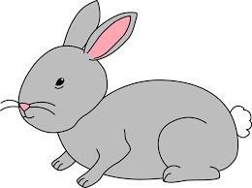
Home Learning Challenge 20/4/20
Challenge 1 – Counting in steps of 2, 5 and 10
Listen to the song, can you count in steps of 2.
Can you count pairs of socks in twos?
If you look at a sequence of numbers going up in steps of 2 can you fill in any missing numbers or continue the sequence?
Have ago at making your own counting caterpillar in steps of two?
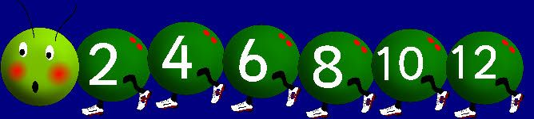

Extension
Can you count in steps of 5 and 10?
Colour the numbers on a hundred square. What patterns do you see?

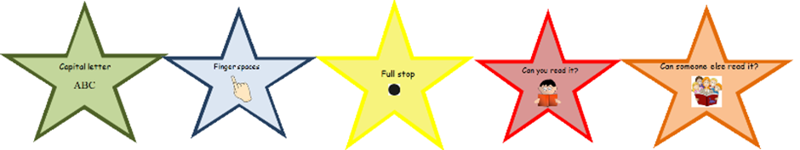
Challenge 2 – Write a description
Watch the video of The Hungry Caterpillar.
Can you write a description of the hungry caterpillar?
What does he look like? How does he move? What does he like to do?
Can you use lots of adjectives?
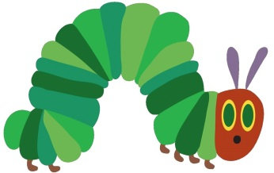
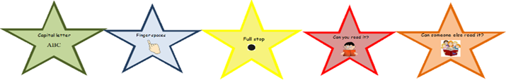

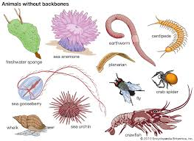
Challenge 3 – Go on an invertebrates hunt!
How many different invertebrates can you see?
Can you name them?
Where do they live?
How are they the same/different?

