Summer Term 1: Week 1 17.4.20
English Task 4
Using your spring word bank and inspiration from the great outdoors, create a spring story.

This could be based on an adventure in the woods, a magic world in your garden or any other creative idea you have!

Use the story mountain plan as a guide to plan your story first.
Remember to include as many SPaG features as you can in your story and your neatest handwriting!
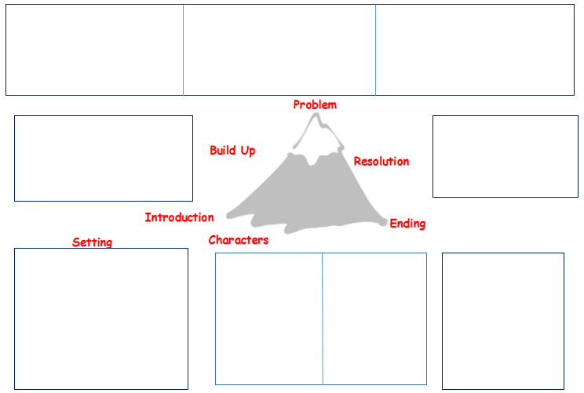

SPaG features to include:
- Capital letters /full stops
- Spellings (common exception words and spelling rules)
- Expanded noun phrases (adjectives)
- Co-ordinating conjunctions (and so but or yet)
- Subordinating conjunctions (because when then after as if )
- Question marks / exclamation marks
- Commas in a list/ apostrophes for omission and possession / story language

