Summer Term 1: Week 1 15.4.20
English Task 2
We know the weather has been lovely over the last few weeks and so hope that you have managed to spend some time observing spring in your own gardens, or out on a walk.
Mrs Machin has spotted her daffodils in her garden and some new spring flowers coming through.
We would like you to use the spring time as inspiration for a shape poem.
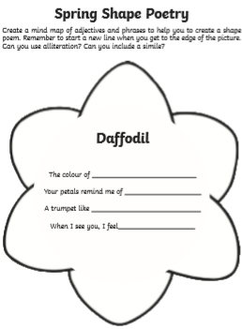
Draw a spring picture and create a poem for the shape. Then record your poem within the shape.
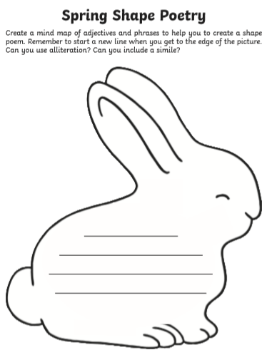
There are some ideas and examples below.
