Summer Term 1: Week 1 14.4.20
Science task
Lava Flow Experiment

Can you work like a scientist to create a lava flow using things that you can find around your home?
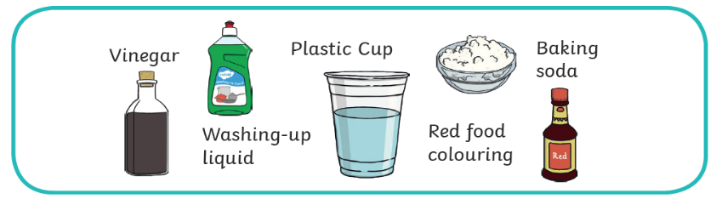
Equipment:

Method:
- Fill your glass just over half full with water, add 3 tea spoons of baking soda and give it a good stir until most of the baking soda dissolves. Then add 3 drops of red food colouring and stir until it turns red.
- Add a good squirt of washing up liquid into the cup and once again give it a stir.
- Make sure your volcano is in the kitchen or outside (or somewhere you don’t mind making a mess).
- Quickly pour in just under a quarter of a cup of vinegar and enjoy your very own volcanic eruption!
Can you take pictures and write out your experiment? Use these headings:
Equipment
Method
Results – What happened when you mixed your ingredients?
Pictures – take photographs or draw what happened
Can you try to change your experiment and predict what will happen? What if you put in half the amount of vinegar? Or if you pour the vinegar in more slowly? Remember – it will only be a fair test if you any change one part of your experiment.

Why did it work?
You just made a chemical reaction! By mixing the acid (vinegar) and the alkali (bicarbonate of soda), bubbles of carbon dioxide (CO2) were released like in a pyroclastic flow.

