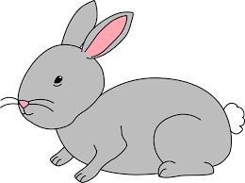
Home Learning Challenge 6/4/20
Challenge 1 – Money
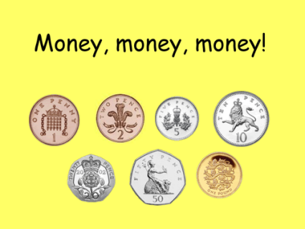
Can you recognise different coins? (1p, 2p, 5p, 10p, 20p)
Make a snack price list. Can you find the total cost of
different snacks and pay using 1p coins?
Can you count out the number of 1p coins to represent
2p, 5p, 10p and 20p
Extension
How many different ways can you make 10p/ 20p using
different coins?

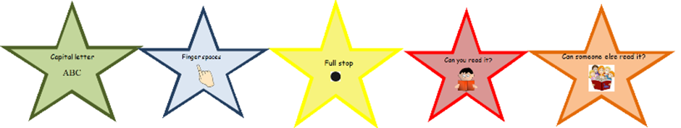
Challenge 2 – Write instructions
Make a jam sandwich!
Can you remember what you did and sequence the events?
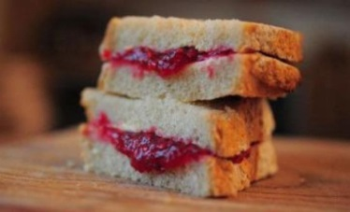
Can you write your own instructions for someone else?
Can you number your instructions?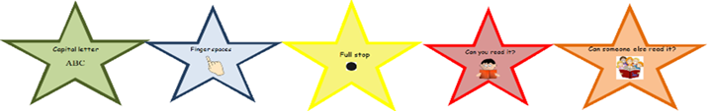
Remember to check your work using the writing stars.

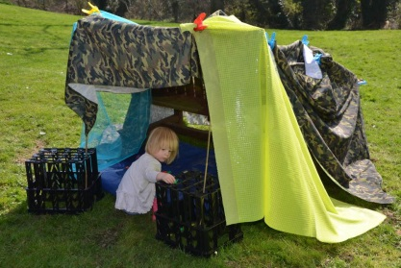
Challenge 3 – Make a Den
Can you make your own den?
You could make one inside or outside.
Could you make signs to put on your den?
Take a photograph and share it with your teachers!

