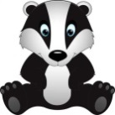
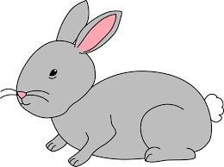
Home Learning Challenge 30/3/20
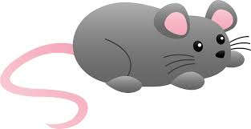
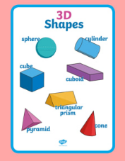
Challenge 1 – 3d shapes
Can you name these 3d shapes?
Have a look around your house, what 3d shapes can you see?
Can you build a model using 3d shapes?
Can you name the shapes you have used?
Extension
Can you count the number of faces, edges and vertices?

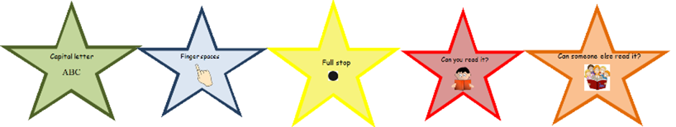
Challenge 2 – Write a silly sentence
Read the sentence to your child.
Can they repeat it back to you?
Can they write it down independently?
Can they check their work using the writing stars?
Can they illustrate it!
The following sentences link to the children’s book band colour.
 | The fat cat had a hat.
 | The chick sat in the bath.
 | I can see a pink owl in the tree at night.
And above | The green sheep went for ride on his bike.

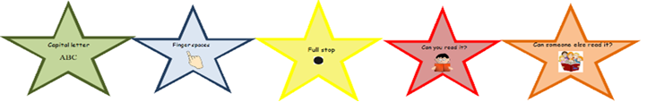
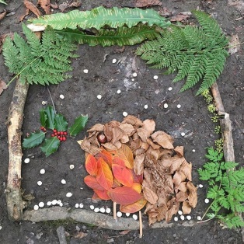
Challenge 3 – Natural Sculptures.
Look in your garden and make a collection of natural objects.
Can you name the things you have collected?
How are they the same and different?
Can you arrange them to make a natural collage or sculpture?

