Communication and Language  Play the ‘How many claps?’ game using the picture cards below. Each player chooses a card and says the name of the object in the picture. The other play claps the number of syllables in the picture. For example, butt-er-fly has 3 syllables, so you would clap once for each of the 3 syllables. If you clap correctly, you keep the card. They player with the most cards at the end of the game is the winner! | Personal, Social and Emotional Development  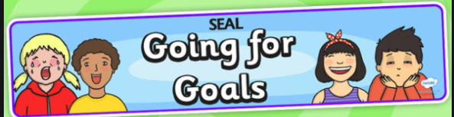  Talk about what you can do already and what you would like to get better at. Complete the ‘Going for Goals’ activity sent home last week ready to return it to school for our SEAL display. | Physical Development  We are learning how to move our bodies in lots of different ways. Can you move like the different characters in ‘Jack and the Beanstalk’? You could take huge, stomping steps like the giant, or tiptoe quickly like Jack sneaking into the castle. You could send your teacher a video of you showing off your moves.
Reading  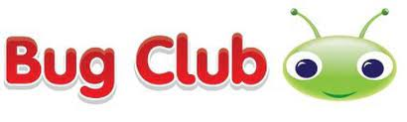  Use your Bug Club login (password sent home on blue bookmark).  Read, or watch, ‘Jack and the Beanstalk’ using the link below and talk about the main events in the story. Would you climb the beanstalk? Why or why not? https://www.bbc.co.uk/iplayer/episode/p08lc99s/mr-tumble-tales-jack-and-the-beanstalk | Writing  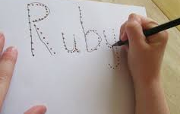  Practise writing your name. Remember to hold your pencil near to the tip!  Have a go at our writing activity (attached to the gallery page). Use ‘Fred Fingers’ to check how many sounds you are listening for, then use the sound mat below to find the sound and write it down. You could challenge yourself by writing a super sentence using one of the words you have written. | Number and Numerical Patterns  We have begun to add two groups together to find a total. Start off by adding (within 10) using resources you have at home, such as pasta shells, cereals or pencils/pens. You could have a go at writing an equation to match. For example;  + = 5  3 + 2 = 5
Understanding the World  We have been exploring ice as part of our learning about winter. Add food colouring to water and freeze at home. When the ice is ready, use it to create an ice paint picture. What happens to the ice when you take it out of the freezer? Talk to a grown up about what you notice about freezing and melting. | Expressive Arts and Design  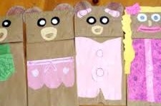  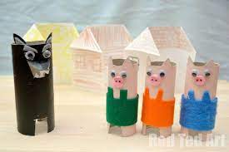  Design a character from your favourite fairy tale or traditional tale. What will you need to make your creation? You could paint, add wool, sequins, tissue paper or even make a junk model instead. Take a photograph of your creation and send it to your teacher.  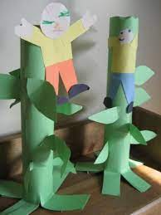 | Useful websites to practise and consolidate learning  www.topmarks.co.uk – select Early Years and choose from the games and activities listed.  www.phonicsplay.co.uk – select Resources, and then either Phase 1 or Phase 2.  http://www.crickweb.co.uk/Early-Years.html - select Early Years choose from the games and activities listed.
Foundation Stage 2 – Home Learning Menu January 2022
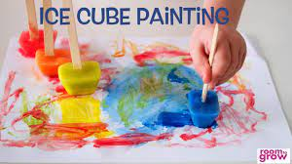
Syllable clapping game
