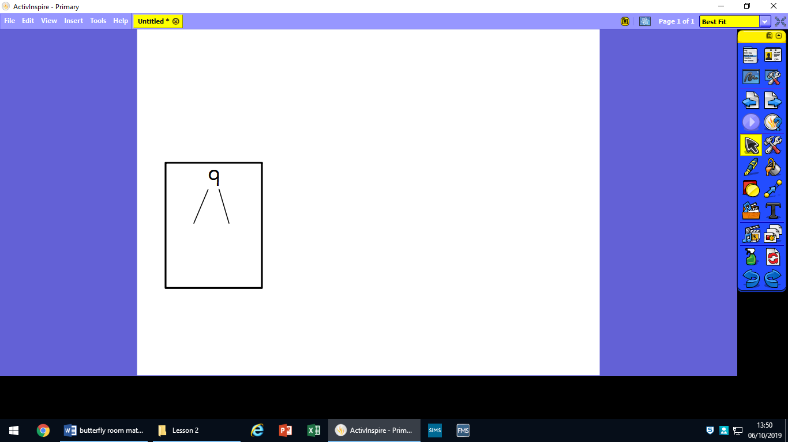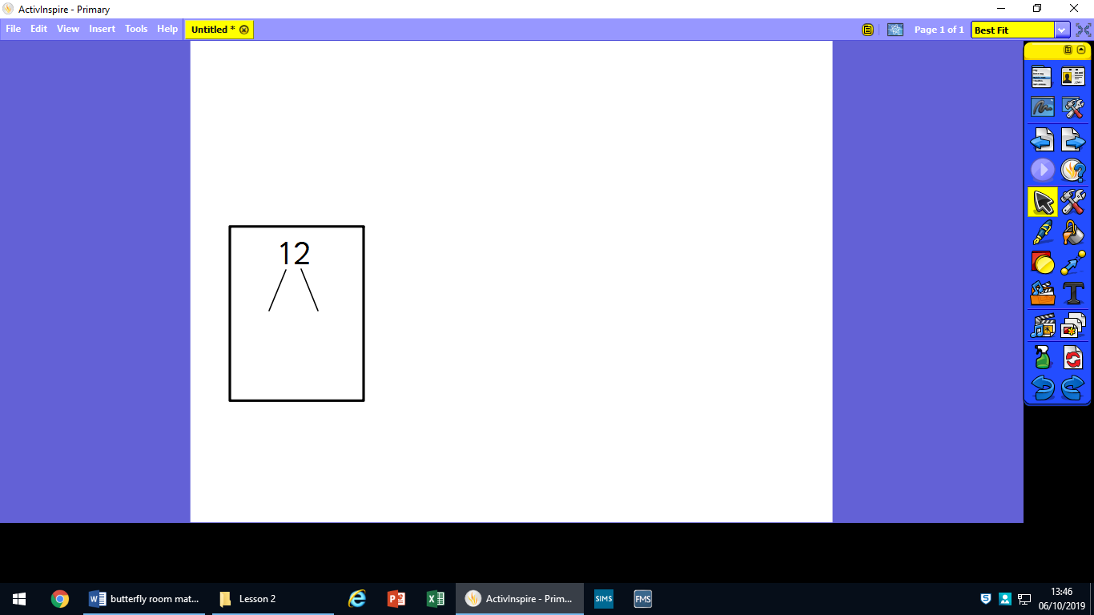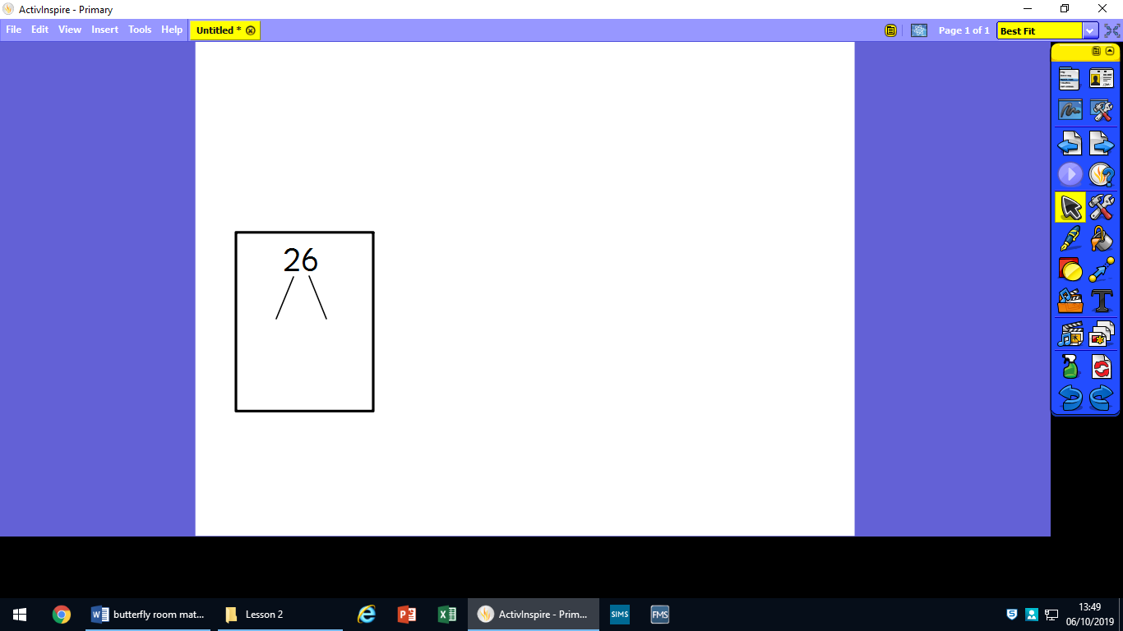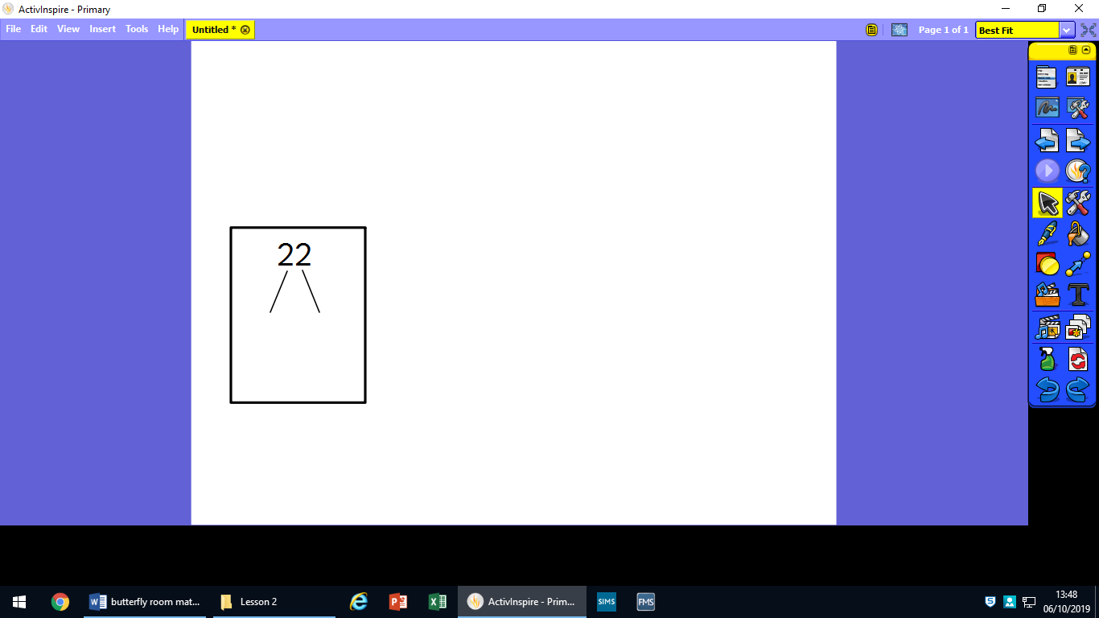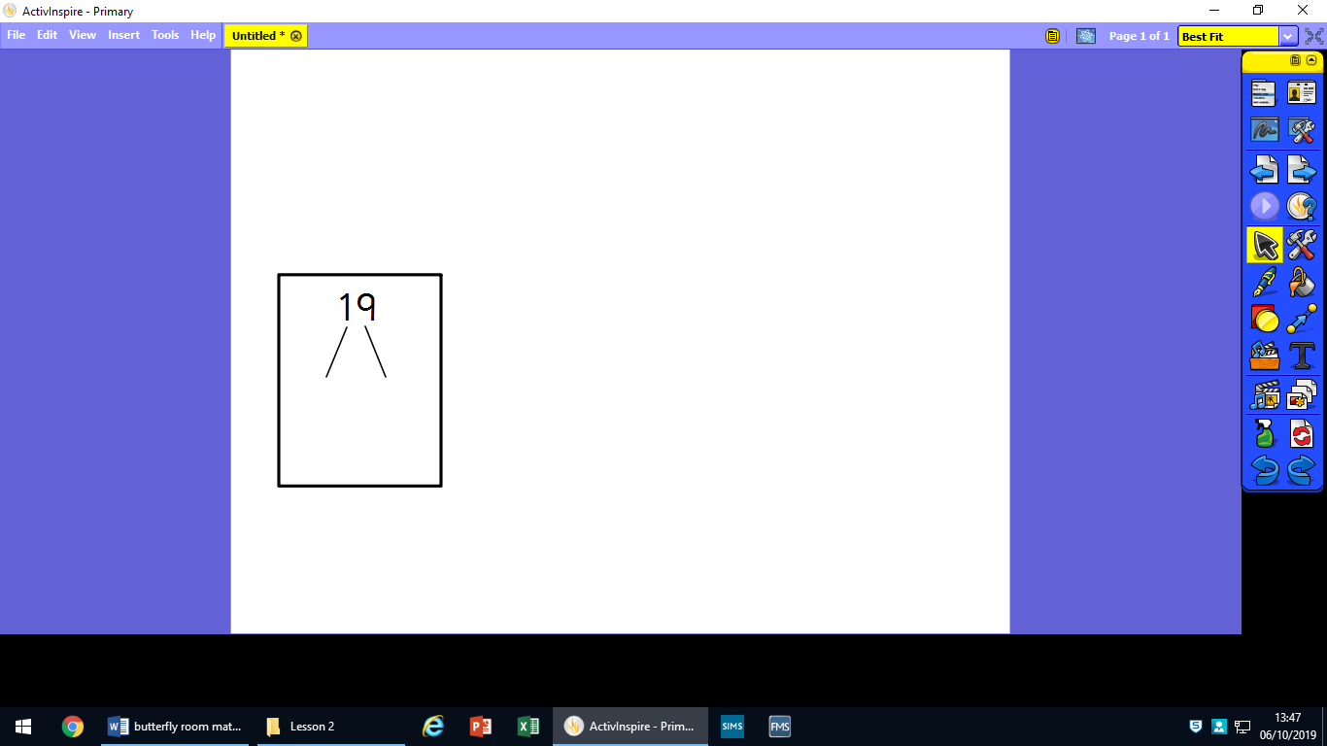Draw out the 10s and ones for these numbers:

26

43

37

51

16

19

**Circle your groups.**

**One has been done for you.**

**12 ÷ 3 =**

**8 ÷ 4 = 2**



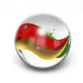

**8 ÷ 2 =**

**9 ÷ 3 =**

**6 ÷ 2 =**

**15 ÷ 5 =**

 



