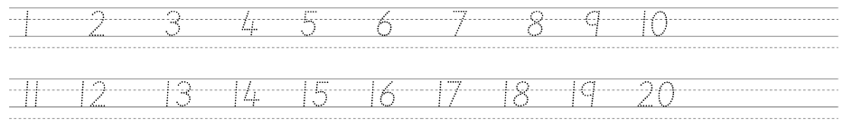







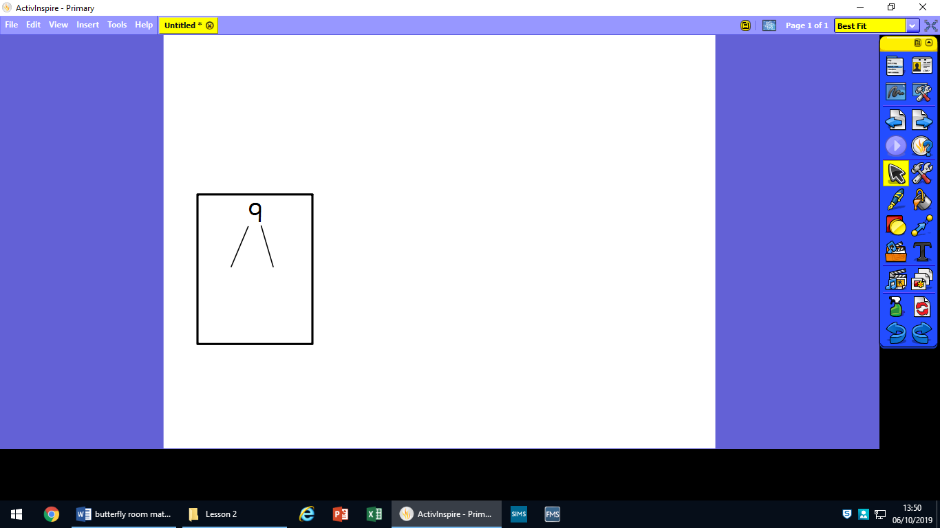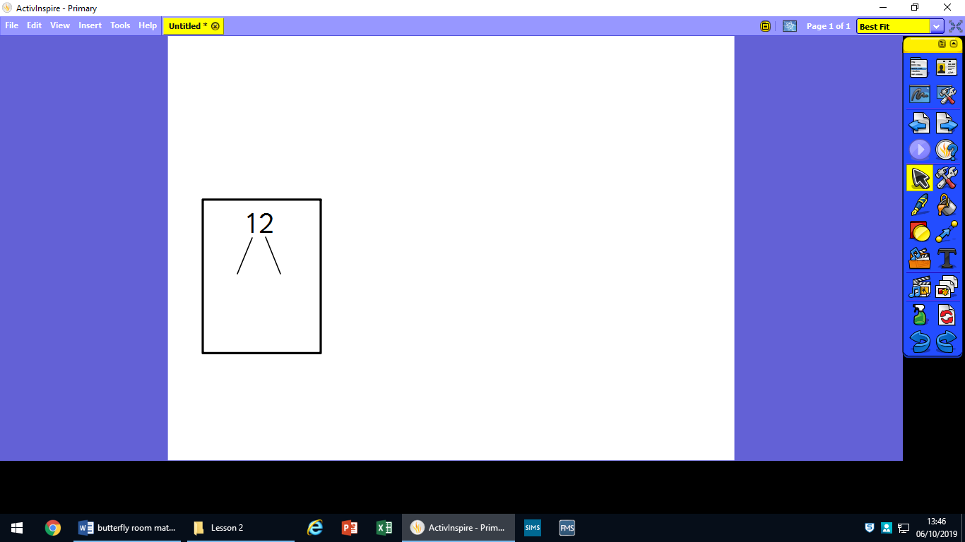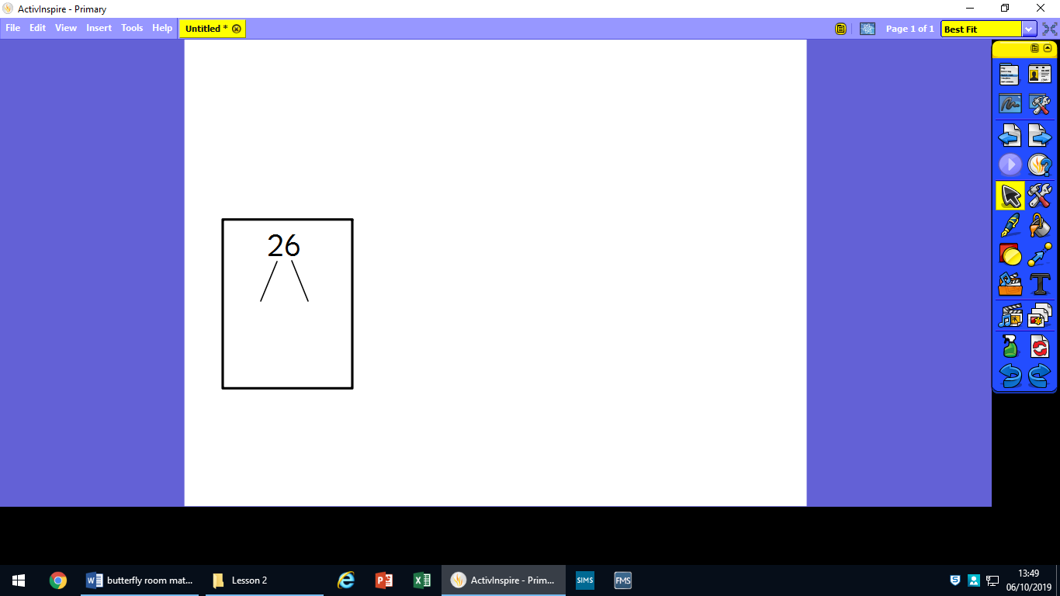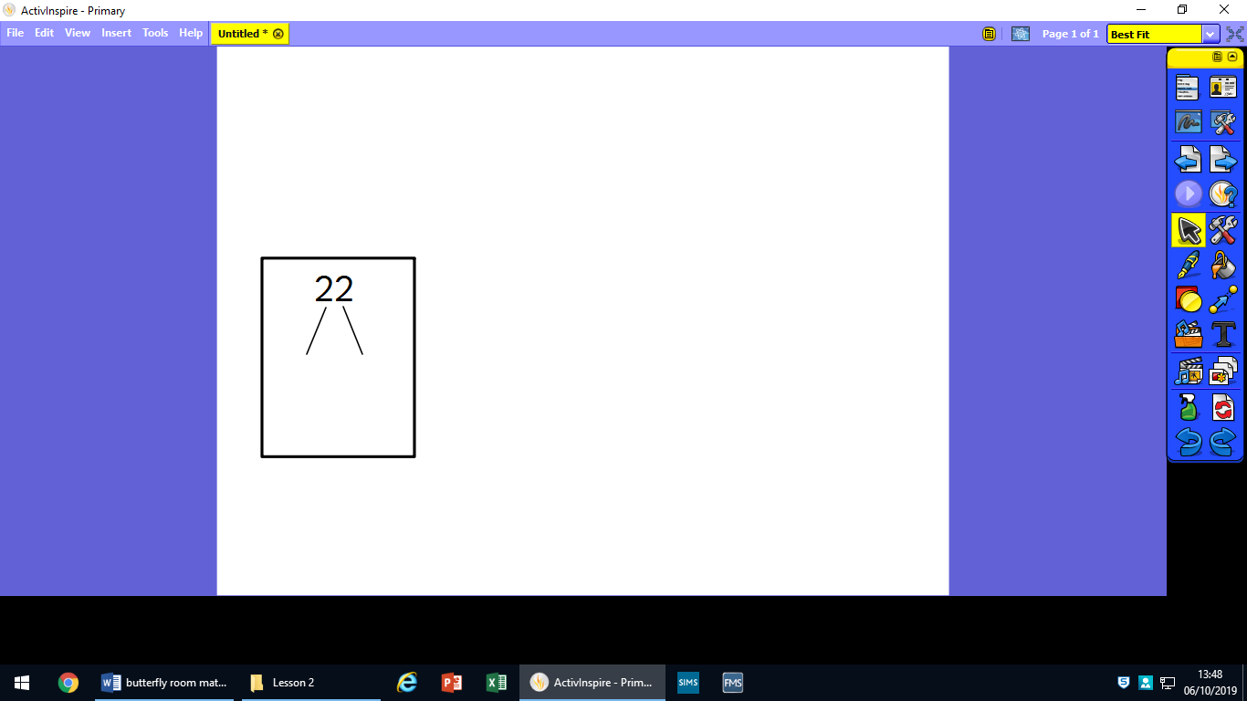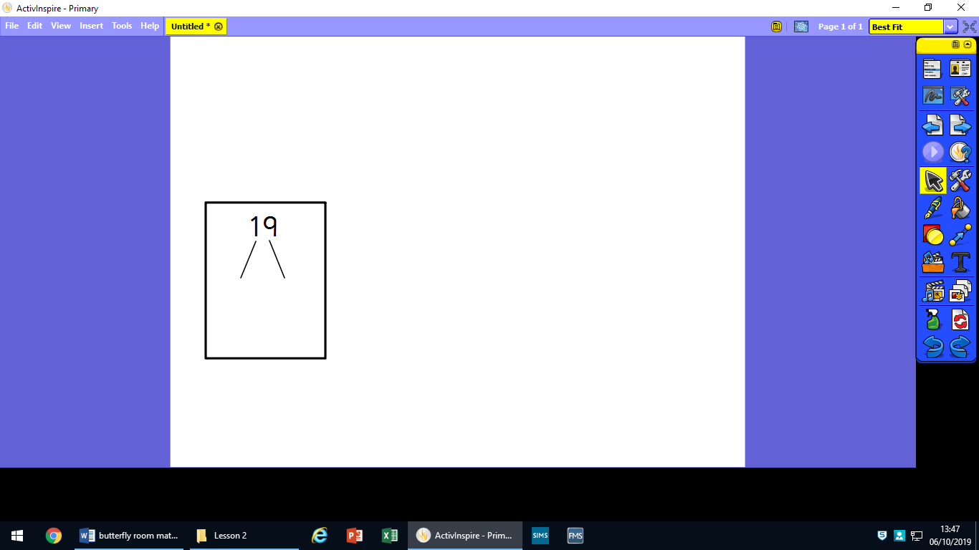Draw out the 10s and ones for these numbers:

17

26

33

43

15

39

**Draw your tens and ones for the calculations.**

**One has been done for you.**

**12 + 7 =**

**11 + 6 =**

**13 + 5 =**

**18 - 7 =**

**16 - 4 =**

**14 - 2 =**