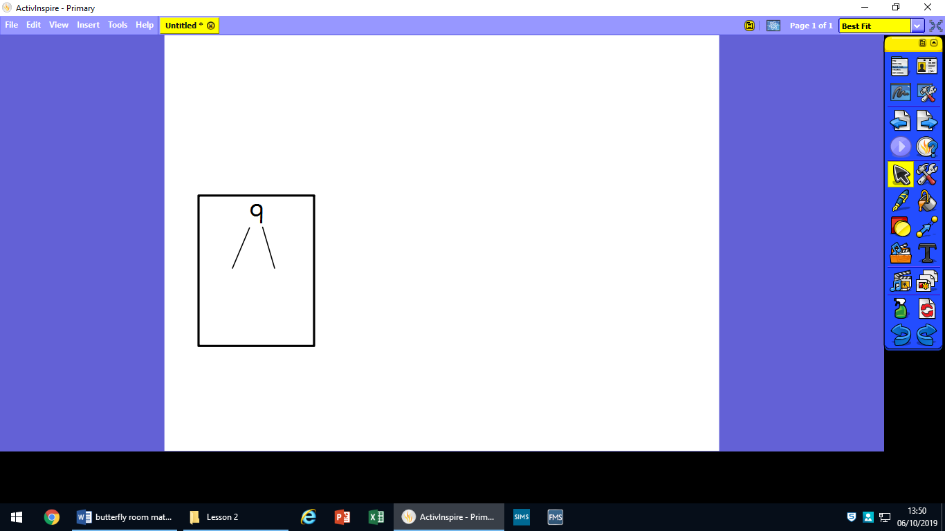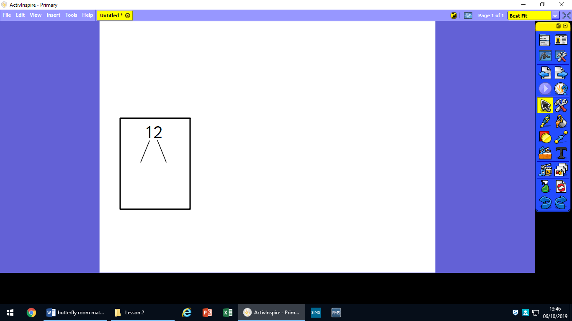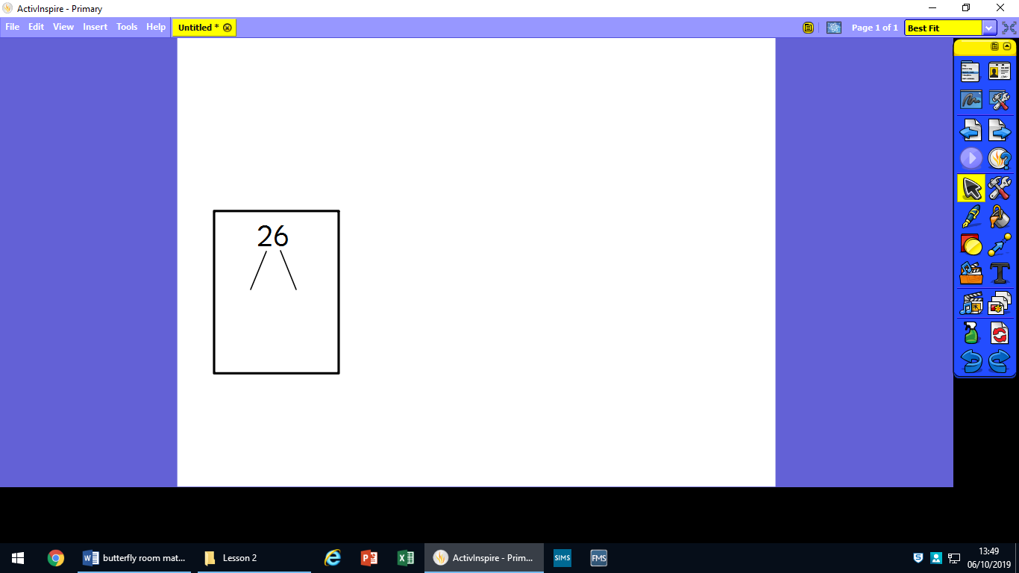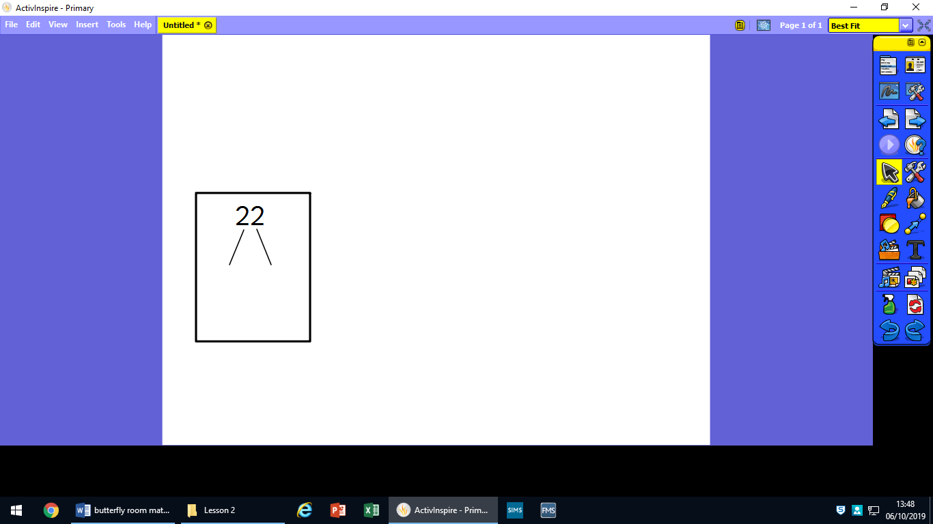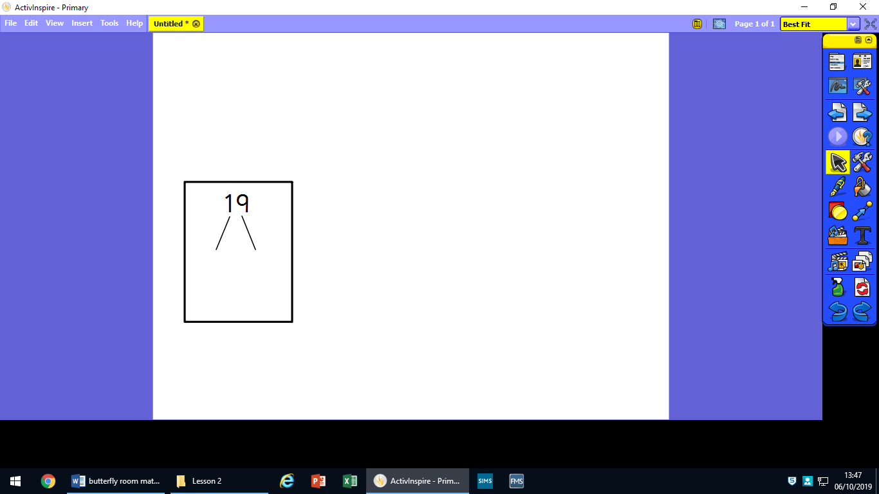Draw out the 10s and ones for these numbers:

36

23

47

21

13

29

**Draw your groups for the calculations.**

**One has been done for you.**

**15 ÷ 3 =**

**8 ÷ 4 = 2**

**10 ÷ 2 =**

**12 ÷ 3 =**

**12 ÷ 2 =**

**25 ÷ 5 =**