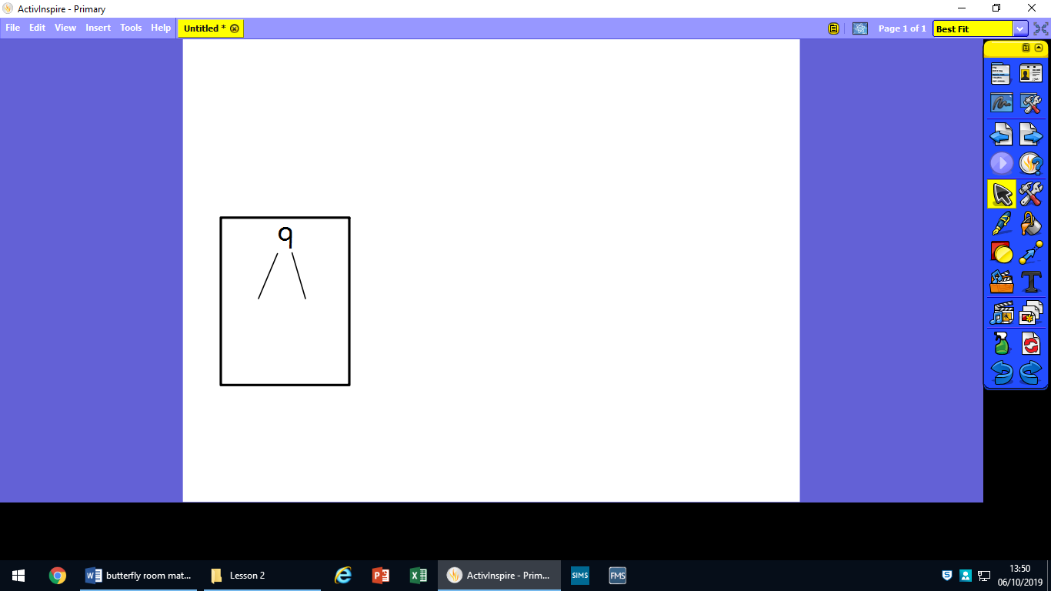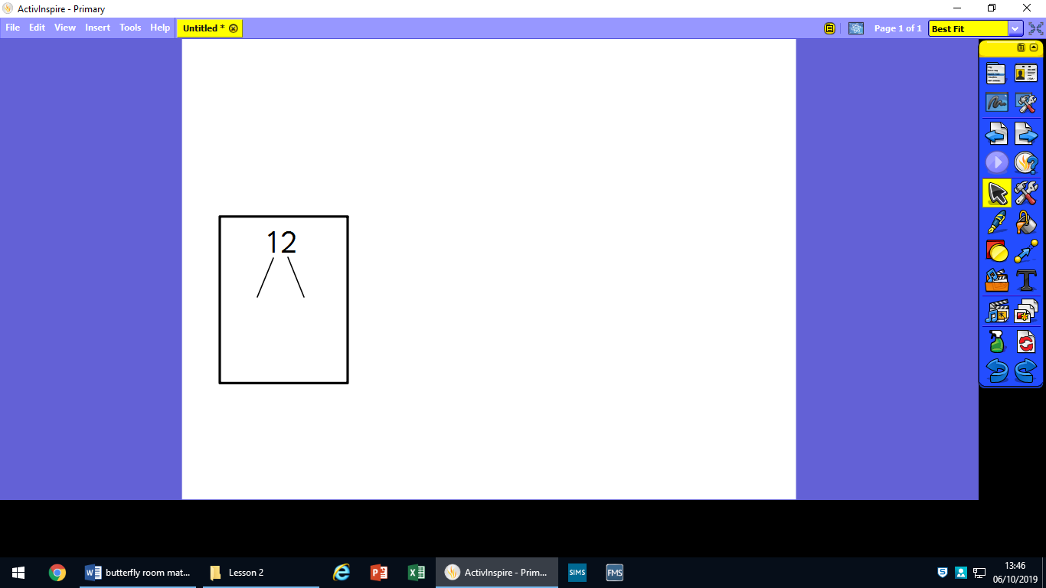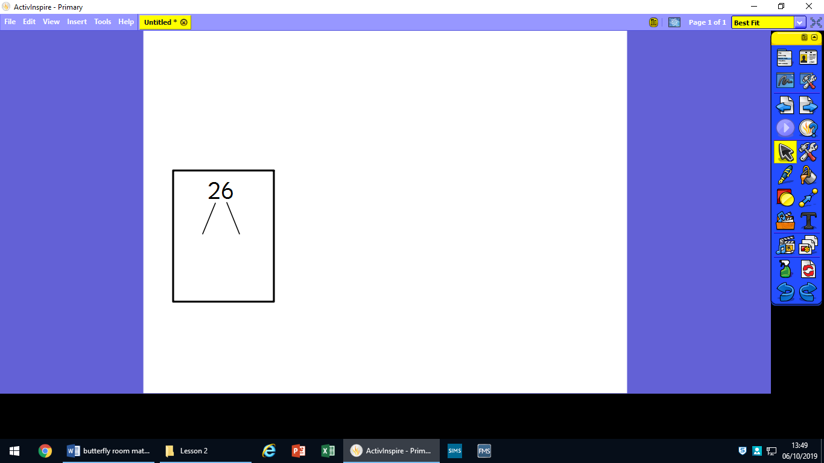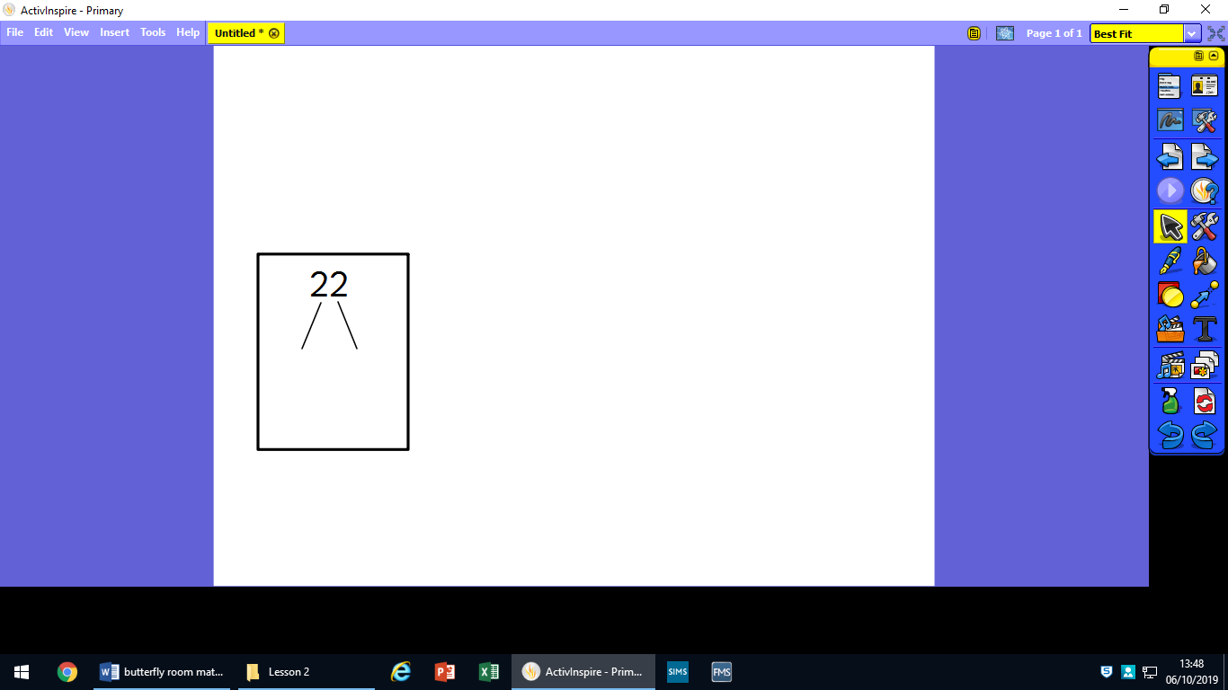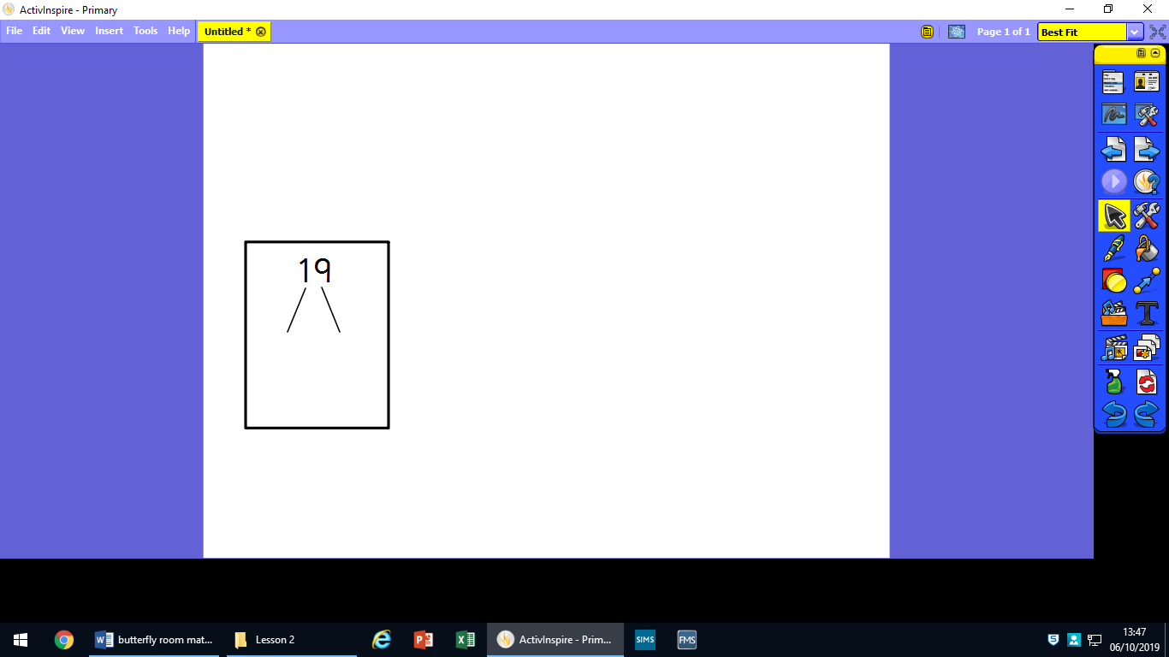Draw out the 10s and ones for these numbers:

19

22

31

40

14

35

Draw out the 10s and ones for these numbers:

17

26

28

30

21

43

Draw out the 10s and ones for these numbers:

29

32

11

44

27

15