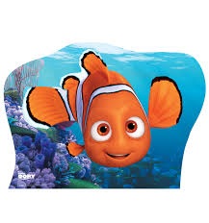

Write out these present tense sentences in your book. Change them into past tense sentences and write them again. Underline the verbs in orange.

- Nemo is searching for his dad Marlin.
- Dory is swimming through the warm, turquoise sea.
- Crush is listening carefully to Marlin’s story.
- Bruce the shark is chasing Dory and Marlin through the old, broken shipwreck.
- Dory is always forgetting where she is going.

Can you create your own past tense sentences about finding Nemo?

Write out these present tense sentences in your book. Change them into past tense sentences and write them again. Underline the verbs in orange.

- Nemo is searching for his dad Marlin.
- Dory is swimming through the warm, turquoise sea.
- Crush is listening carefully to Marlin’s story.
- Bruce the shark is chasing Dory and Marlin through the old, broken shipwreck.
- Dory is always forgetting where she is going.

Can you create your own past tense sentences about finding Nemo?

