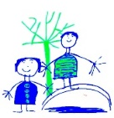

**History:**

To learn and recall facts about real events beyond living memory and order events on a timeline.

**Star Words:**

Timeline, past/present/future, then and now, chronological.

**Key Knowledge:**

To order the key events of the Great Fire of London chronologically.

What the significant events that happened during The Great Fire of London were.

To explain how we know this event happened in the past.

To compare images of London from the past and present (then and now).

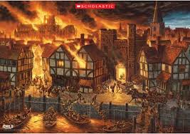

**Additional Information:**

Trips: 6th March – The Emergency Vehicle Museum

12th March, 9:15 – Y1 phonics meeting

Word Mats Available on Class Blogs

**Science:**

To observe changes across the four seasons.



**Star Words:**

Weather, spring, germination, day, night, daytime, sleet, fog, snow, sun, wind, rain, hot, warm, cold.

**Key Knowledge:**

Seasonal changes:

What seasonal changes we see in the UK in spring; weather, length of days, key events/celebrations.

**Maths and English:**

English Text: Toby and The Great Fire of London

Please see the class ‘Ask Me About Board’ for regular updates regarding our Maths and English learning.

**RE:**

We will be listening to and recall key facts for stories from Christianity e.g The Good Samaritan.

For children to know that the Bible is an important book to Christians and that it contains many different special stories.

**Star Words:**

Christianity, Bible, Islam, Koran, Church, Synagogue, Mosque, Humanist.

**Other Curriculum Areas:**

**PE:** Hedgehogs – swimming and skipping skills. Gymnastics – applying balances and travelling onto apparatus. Games – striking and fielding skills.

**Computing:** How to be safe on the internet – how to keep your personal information safe.

**Personal, Social, Health Education:** Feelings and Emotions – What feelings we have, what causes them and how we can manage them?

**Art:** To identify and name the primary colours and mix these to create secondary colours.

**Geography:** Recap what the countries of the UK and their capital cities are. To be able to identify London in relation to Sheffield. (Key words: North, South, East, West)

**Ice and Fire – Spring 2**