|  |  |  |  |  |  |
| --- | --- | --- | --- | --- | --- |
| ***‘To provide a foundation for fulfilled lives, inspiring confident and happy learners’*** | | | | | |
| Enjoy learning | Try our best | Make good choices | Respect each other & our surroundings | Work together | Celebrate our successes |
|  |  |  |  |  |  |

***Dobcroft Infant School***

**In the Foundation Stage**,

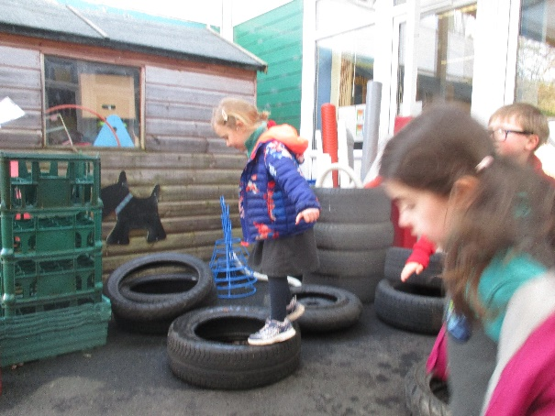The children are taught how to build upon their own experiences and work towards achieving the Early Learning Goal (ELG) for Personal, Social and Emotional Development. This is divided into three main areas of Making Relationships, Self-confidence and Self Awareness and Managing Feelings and Behaviors.

The SEAL (social and emotional aspects of learning) national strategy informs our teaching and children have weekly seal circle time sessions covering different themes each half term

**In Key Stage 1**

our PSHE curriculum covers work on relationships and Health and Wellbeing. Children focus on a different theme each half term:

|  |  |
| --- | --- |
| Autumn 1  Community | Spring 2 Feelings |
| Autumn 2  Friends | Summer 1 Physical Health |
| Spring1  Family | Summer 2 Growing up |

In KS1 the children are taught skills and rules for staying healthy and safe and for behaving well. Children are given opportunities to show they can take some responsibility for themselves and their environment. They begin to learn about their own and other people’s feelings and become aware of the views, needs and rights of others. They learn social skills such as how to share, take turns, play, help others, resolve simple arguments and resist bullying.

In line with the Sheffield RSE guidance the teaching of sex education begins in KS2 and is not covered within our school.

**PSHE at Dobcroft**

**At Dobcroft Infant School our personal, social and health education is embedded in to our school ethos and curriculum.**

**Seal 5Pastoral Care**

* Strong anti-bullying ethos
* Playground leaders to initiate games
* A friendship stop
* Turn around Boxes for children to emotionally regulate.
* Weekly PSHE circle times
* [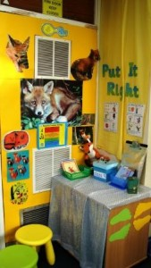](http://foxes.dobcroftinfants.net/files/2013/09/classroom-005.jpg)Put it Right areas in each classroom
* Golden Moments reward system
* Class contracts created by each class
* Strong staff team plus teaching assistant support
* The Club to support children at lunchtime
* Trained welfare Supervisors support children
* The Butterfly Room – a nurture room to support vulnerable learners
* Praise and positive behaviour management systems.
* Tracking of behavioural incidents and parental concerns

**How you can help at Home**

* Encourage your child to dress and undress independently and manage their own hygiene.
* Provide a role play area resourced with materials reflecting your child's interests.
* Encourage your child to help you think about cooking and healthy recipes. Take them shopping and involve them in decision making.
* Simple activities such as board games encourage team-work and help children learn to take turns.
* Help your child to see another person’s point of view and understand it may be different to their own.
* Recognise when your child is getting upset/ angry and model remaining calm yourself.
* Try saying “I understand that you are feeling cross…”
* Practise calming down strategies:-
* Slow breathing / counting to 10 / making fist flowers etc
* Give plenty of positive encouragement and praise.

