Dashing through the snow
In a one-horse open sleigh
O'er the fields we go
Laughing all the way (ho ho ho)
Bells on bobtails ring
Making spirits bright
What fun it is to ride and sing
A sleighing song tonight!
Oh
Jingle bells, jingle bells,
Jingle all the way.
Oh! what fun it is to ride
In a one-horse open sleigh (hey!)
Jingle bells, jingle bells,
Jingle all the way;
Oh! what fun it is to ride
In a one-horse open sleigh. Repeat
Jingle Bells

Silent night, holy night!
Son of God love's pure light.
Radiant beams from Thy holy face
With the dawn of redeeming grace,
Jesus Lord, at Thy birth
Jesus Lord, at Thy birth
Silent Night

Silent night, holy night!
All is calm, all is bright.
Round yon Virgin, Mother and Child.
Holy infant so tender and mild,
Sleep in heavenly peace,
Sleep in heavenly peace

Silent night, holy night!
Shepherds quake at the sight.
Glories stream from heaven afar
Heavenly hosts sing Alleluia,
Christ the Savior is born!
Christ the Savior is born

Later on, we'll conspire,
As we dream by the fire
To face unafraid,
The plans that we've made,
Walking in a winter wonderland.

In the meadow we can build a snowman,
And pretend that he's a circus clown
We'll have lots of fun with mister snowman,
Until the other kids knock him down.

When it snows, ain't it thrilling,
Though your nose gets a chilling
We'll frolic and play, the Eskimo way,
Walking in a winter wonderland. x 2

Winter Wonderland
Sleigh bells ring, are you listening,
In the lane, snow is glistening
A beautiful sight,
We're happy tonight.
Walking in a winter wonderland.

Gone away is the bluebird,
Here to stay is a new bird
He sings a love song,
As we go along,
Walking in a winter wonderland.

In the meadow we can build a snowman,
Then pretend that he is Parson Brown

He'll say: Are you married?
We'll say: No man,
But you can do the job
When you're in town.

Away in a Manger
Away in a manger, no crib for a bed,
The little Lord Jesus lay down his sweet head.

The stars in the bright sky looked down where he lay,
The little Lord Jesus asleep in the hay.

The cattle are lowing, the baby awakes,
But little Lord Jesus no crying he makes.

I love Thee, Lord Jesus, look down from the sky
And stay by my side until morning is nigh.

Be near me, Lord Jesus, I ask Thee to stay
Close by me forever, and love me, I pray.

Bless all the dear children in thy tender care,
And take us to heaven, to live with Thee there.

Rudolph the red-nosed reindeer (reindeer)
Had a very shiny nose (like a light bulb)
And if you ever saw it (saw it)
You would even say it glows (like a traffic light)
All of the other reindeer (reindeer)
Used to laugh and call him names (like Pinochio)
They never let poor Rudolph (Rudolph)
Join in any reindeer games (like Monopoly)
Then one foggy Christmas Eve
Santa came to say (Ho Ho Ho)
Rudolph with your nose so bright
Won't you guide my sleigh tonight? (Gee Santa I'd love to)
Then all the reindeer loved him (loved him)
And they shouted out with glee (with glee)
"Rudolph the red-nosed reindeer (reindeer)
You'll go down in history!" (like Elvis)
Rudolph

Oh little town of Bethlehem
How still we see thee lie
Above thy deep and dreamless sleep
The silent stars go by
Yet in thy dark streets shineth
The ever-lasting light
The hopes and fears of all the years
Are met in thee tonight

For Christ is born of Mary
And gathered all above
While mortals sleep, the angels keep
Their watch of wondering love
O morning stars together
Proclaim the holy birth
And praises sing to God the king
And Peace to men on earth
O Little Town of Bethlehem

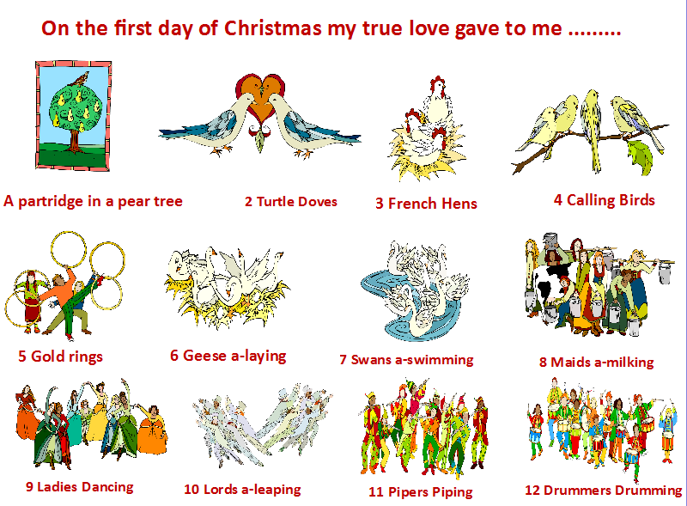
We Wish You A Merry Christmas
We wish you a Merry Christmas
For we all like figgy pudding
For we all like figgy pudding
For we all like figgy pudding
So bring some out here!

Good tidings we bring
To you and your kin
We wish you a Merry Christmas
And a Happy New Year

We wish you a Merry Christmas
We wish you a Merry Christmas
And a Happy New Year

Good tidings we bring
To you and your kin
We wish you a Merry Christmas
And a Happy New Year

Now bring us some figgy pudding
Now bring us some figgy pudding
Now bring us some figgy pudding
And a cup of good cheer

And we won't go until we've got some
And we won't go until we've got some
And we won't go until we've got some
So bring some out her

