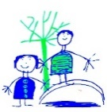
Home reading at Dobcroft – info for parents
Children will receive 3 books a week (at least) to read at home.
Shared reading with an adult
One will be sent home in the red book bag and this will be chosen by the child from our school library. This might not be at a phonetically decodable level for the child and should be a book to share and enjoy with an adult.
The second book will be chosen by the child from the coloured book boxes in the classroom. This is aimed at your child’s reading level however it should still be a shared read with an adult for consolidation and pleasure as some words and sounds could be unfamiliar.
Independent reading
The third book sent home will be a ‘Read Write Inc’ book bag book. This book will be linked directly to the book the children have been reading in class. The sounds will all be familiar and decodable at your child’s assessed level therefore this should be read by the child. This is the book that will be changed by your child’s teacher once a week. The corresponding book your child has been reading in class will also be available as a link to our online e-library so your child can access this book again to read at home if they wish.
Once your child has moved off the Read Write Inc. programme they will not receive a RWI book or Book Bag Book and they will only receive a coloured book box book and library book. They should be confident readers to segment and blend using their phonics.
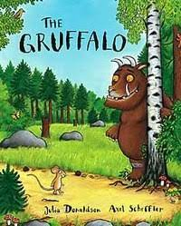
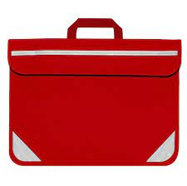
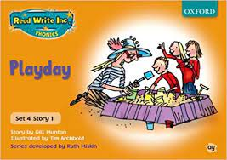
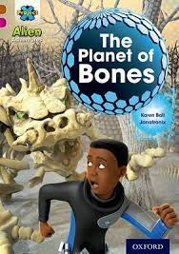
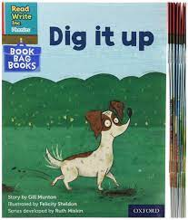
3.
2.
1.

