‘To provide a foundation for fulfilled lives, inspiring confident and happy learners’
Enjoy learning | Try our best | Make good choices | Respect each other & our surroundings | Work together | Celebrate our successes
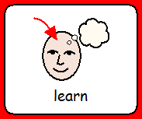 | 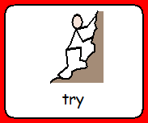 | 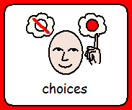 | 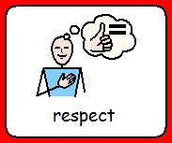 | 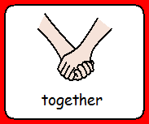 | 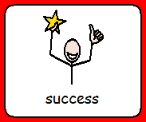

Dobcroft Infant School

Our Vision:
In Geography we aim to stimulate interest and wonder in the world around us. We study people and places and learn to understand how they relate to each other. We learn about features of human and physical geography and equip pupils with the vocabulary to describe them, developing empathy for people living in different places. Our curriculum helps children to develop an understanding of our locality and cultures as well as those of others through the study of other places. Lessons help children develop an awareness of the environment and their responsibility to care for it. We encourage an appreciation of what ‘global citizenship’ means and the global ‘rights of the child’, linked to our school’s work as a Unicef Rights Respecting school. Our aim is to enable the development of a variety of skills including those of enquiry, problem solving, ICT and investigation. This includes map work and basic compass skills. Through this we aim to grow enquiring, curious and enthusiastic geographers!

Our Curriculum:
Teaching and Learning
EYFS
Children are taught about Geography through the subject Understanding the World. Children know about similarities and differences in relation to places, objects, materials and living things. They talk about the features of their own immediate environment and how environments might vary from one another. They make observations of animals and plants and explain why some things occur, and talk about changes. Much of this is taught using the outdoor learning areas and the natural environment.
In KS1 teachers use a variety of teaching and learning styles in geography lessons. The principal aims are to develop skills and understanding as well as developing their technical knowledge. We do this through a mixture of whole-class teaching and individual/group activities. Within lessons, we give children the opportunity both to work on their own and to collaborate with others, listening to other children’s ideas and treating these with respect.
We teach the 10 key geographical concepts:
- Place
- Space
- Scale
- Interdependence
- Physical and Human Processes
- Environmental Impact
- Sustainable Development
- Cultural Awareness
- Cultural diversity

Fieldwork
Fieldwork is integral to good geography teaching, and we include as many opportunities as we can to involve children in practical geographical research and enquiry. Examples including visiting a British seaside, exploring the local area (Abbeydale Industrial Hamlet) including nearby woodland, urban areas (e.g Sheffield City Centre) and the Peak District National Park.
For health and safety issues regarding fieldwork, our school follows the guidance contained in its policies on Off-Site Visits and on Health and Safety and carries out thorough risk assessments.
Geography and Inclusion
All children will have access to the Geography curriculum regardless of ability, gender and race. The whole School Policy on Equal Opportunities will apply through the geography curriculum. Pupils of all abilities will be taught with their own class. Their thinking will be supported or extended through targeted questioning and differentiated work which will allow for the development of geographical enquiry at the appropriate level. As well as drawing on materials from different levels of study, teachers may plan further differentiation by extending or reducing the breadth of study. Very occasionally special arrangements will be made for an exceptionally gifted pupil or a pupil with complex and significant needs. They may follow an individualised programme of work or may receive adult support. We strive hard to meet the needs of those pupils with special educational needs, those with disabilities, those with special gifts and talents, and those learning English as an additional language, and we take all reasonable steps to achieve this.

How you can help:
Talk to your child about the world at a level that is appropriate to them. Watch BBC Newsround and discuss world stories and issues. Look at a world map, globe, an atlas, or google earth whenever you talk about a country in order for them to gain a global understanding of our planet. Talk about where food comes from and look on packets for the origins of food you buy. Visit different restaurants and sample different cuisines. Show them the sat nav or google maps when you are out and about. Look at the map in the park to show them how to see where they are. Skype or facetime relatives abroad and talk to them about life in another country, Talk about global issues in the news in a way that won’t frighten them – there are lots of clever people working on climate change and although we all need to be aware of how we can help, it is important children can see these issues in a constructive and hopeful light.

https://www.rgs.org/
https://www.natgeokids.com/uk/
https://www.kids-world-travel-guide.com/
https://tutorful.co.uk/blog/learning-geography-useful-websites-and-resources-that-will-rock-your-world#BestGeographyWebsitesandPodcasts

