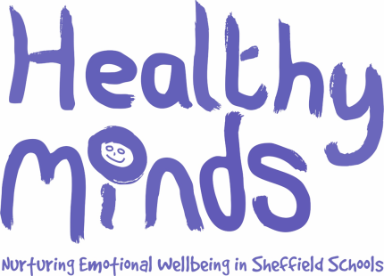

**SLEEP**

**INFORMATION FOR PARENTS**

**Healthy Minds**

**Healthy Minds is a project that is supporting your child’s school in thinking about emotional wellbeing.**

**We have surveyed over 7,000 primary school children in Sheffield and they told us that sleep was a major problem for them.**

* **These are the main reasons that primary school children in Sheffield said that sleep is a problem for them:**

|  |
| --- |
| * **Going to bed too late** |
| * **Being kept awake with worries** |
| * **Room environment (e.g. broken bed/too warm)** |
| * **Parents/carers arguing** |
| * **Looking at screens (e.g. TV, tablet) late at night** |
| * **Watching scary videos/films** |
| * **Being woken up by noisy family members** |

**Useful websites**

[www.thechildrenssleepcharity.org.uk](http://www.thechildrenssleepcharity.org.uk)

[**https://www.sheffield.gov.uk/mast**](https://www.sheffield.gov.uk/mast)

<https://sleepcouncil.org.uk/>

[www.nhs.uk/Livewell/Childrenssleep](http://www.nhs.uk/Livewell/Childrenssleep)

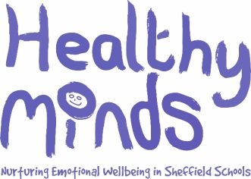

**The importance of sleep**

Sleep is as important to our bodies as food. Sleep is particularly important for children. During sleep:

**• Growth hormones are released**

**• The immune system strengthens, helping your child’s body to fight off illness**

**• The brain makes sense of the day’s events**

**• Memory and concentration functions are increased**

**• Our bodies rest**

**• Emotional wellbeing is restored**

**What is the sleep/wake cycle?**

The “Sleep/wake” cycle is a daily pattern that determines our sleeping pattern. This is often developed through repetitive behaviour/routines we adapt over a period of time.

When it’s time to sleep and we are in an environment that encourages this (e.g. it’s dark outside, lying in our bed), our brain releases a hormone called **melatonin** that encourages us to fall asleep.

During the night we come to partial awakening at the lightest part of the sleep cycle. If the environment is different to how we fell asleep then we may wake up fully. For example, if a child falls asleep with the television on, they may get distressed later in the night when they partially awaken and they can no longer hear or see it.

When it is time to wake up/stay awake throughout the day and we are in an environment that encourages this (e.g. sunlight), our brain releases a different hormone called **serotonin** that encourages us to remain awake.

**SLEEP**

**INFORMATION FOR PARENTS**

