Communication and Language  Retell the story of ‘We’re Going on a Bear Hunt’ by Michael Rosen. Can you think of actions for each part of the story?  Play a game of ‘Simon Says’ with your family. Remember, listen carefully to the instructions and don’t get caught out! If you aren’t sure of the rules, then have a look at the link below. https://thegeniusofplay.org/genius/play-ideas-tips/play-ideas/simon-says.aspx | Personal, Social and Emotional Development  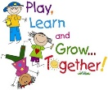  We are developing our turn taking skills by playing board games in the classroom. You could play a game like this with your family at home. We are also thinking about a big question ‘What makes you happy?’ Talk to your family about what makes them happy. Are their answers the same as yours? | 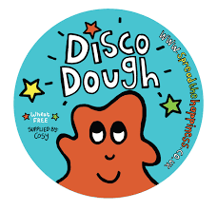  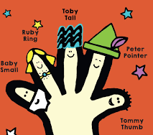  Physical Development  Make playdough using the recipe on the link below. Practise squeezing, rolling, poking and pinching your dough to strengthen your writing muscles. You could head to the dough disco too, by searching ‘Dough Disco’ on YouTube.  https://theimaginationtree.com/best-ever-no-cook-play-dough-recipe/
Reading  Use your new Bug Club login (password sent home on blue bookmark).  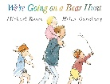  Read ‘We’re Going on a Bear Hunt’ by Michael Rosen, or watch it on YouTube. Can you draw a story map to show the different parts of the story? You could change the ending. What might the family do instead of running from the bear? Have a tea party, or invite him to their house? | Writing  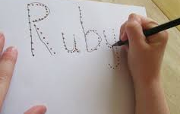  Practise writing your name. Remember to hold your pencil near to the tip!  Look at the picture cards below with a grown up. Can you hear the initial sounds in the words? Practise writing them down using the sound mat below to help you. Can you hear any of the other sounds in the words? Have a go at writing these too. Each picture has a phoneme frame to help you to know how many sounds you are listening for. | Number and Numerical Patterns  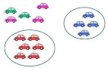  This week we are comparing size, mass and capacity. Choose a mystery box or bowl (any size) and think about what could be inside? Could you fit inside? Why not? What could we fit/not fit inside? Then have a try… Compare to another different sized box or bowl.  Comparing amounts - collect buttons, pasta shells, beads or anything else which can be sorted into sets. Talk to your grown up about which has the most/fewest? How can we check? Count carefully!
Understanding the World  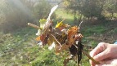  We are thinking about how the world around us changes in different seasons. Head out into the garden and look for signs of autumn. What can you see, hear, smell or feel? You could collect leaves and make a leaf kebab using a stick, or an autumnal picture like the ones below. Don’t forget to send us a photo to share with your friends at school! | Expressive Arts and Design  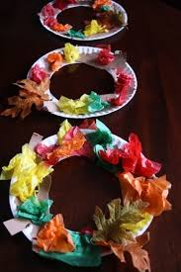  Make an autumn wreath using a paper plate and tissue paper, or an autumnal picture using other things you collect from the garden.  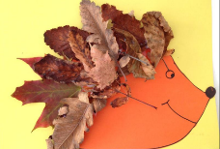  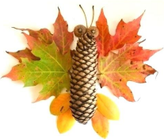  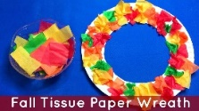 | Useful websites to practise and consolidate learning  www.topmarks.co.uk – select Early Years and choose from the games and activities listed.  www.phonicsplay.co.uk – select Resources, and then either Phase 1 or Phase 2.  https://kids.nationalgeographic.com/ - a great website to promote curiosity about the world around us, with some lovely craft activities too!
Foundation Stage 2 – Home Learning Menu w.c 11th October

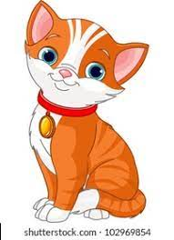
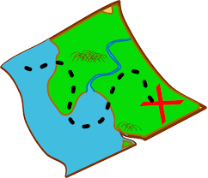
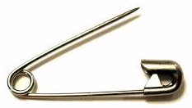
Picture Cards

