Pupil premium strategy statement 2022-25 Dobcroft Infant School
This statement details our school’s use of pupil premium (and recovery premium) funding to help improve the attainment of our disadvantaged pupils.
It outlines our pupil premium strategy, how we intend to spend the funding in this academic year and the outcomes for disadvantaged pupils last academic year.

School overview
Detail | Data
Number of pupils in school | 267
Proportion (%) of pupil premium eligible pupils | 1.85%
Academic year/years that our current pupil premium strategy plan covers (year 2 of 3 2023-24) | 2022-25
Date this statement was published | Dec 2023
Date on which it will be reviewed | December 2024
Statement authorised by | Cathy Rowland
Pupil premium leads | Cathy Rowland/Zoe Singh
Governor / Trustee lead | Sarah Hinchcliffe

Funding overview
Detail | Amount
Pupil premium funding allocation this academic year | £16320
Recovery premium funding allocation this academic year  Recovery premium received in academic year 2023/24 cannot be carried forward beyond August 31, 2024. | £ £2000
Pupil premium funding carried forward from previous years (enter £0 if not applicable) | £0
Total budget for this academic year  If your school is an academy in a trust that pools this funding, state the amount available to your school this academic year | £18,320

Part A: Pupil premium strategy plan

Statement of intent
At Dobcroft Infant School we understand that each child is an individual and as such has completely different needs both educationally and personally. We have high expectations for all children even though some of the pupils for whom the Pupil Premium provides support for are working below the level of their peers, and we have great levels of challenge for all our pupils at all their levels. Our focus is for children to know more and remember more through effective intervention. Through support/identified outcomes we will do
everything we can to help diminish the difference between pupils with PP, and those
without, to enable them to be successful in the next stage of their education and beyond.

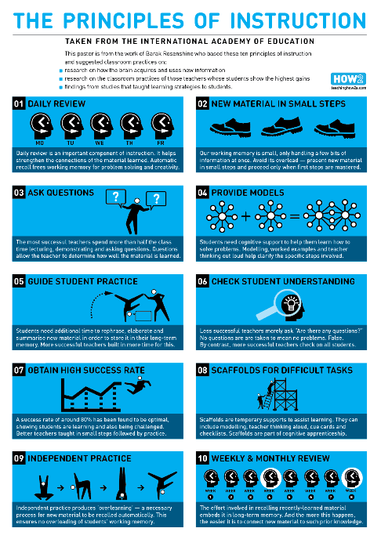
In some cases, this support may be through time spent in the intervention /nurture room, receiving or one to one intervention based on their specific learning needs or gaps in knowledge. We as a school, also understand that there may also be other social, emotional or psychological, barriers to learning as a result of the experiences in their lives and we are working with external professionals to ensure that we address them appropriately. Our aim is to ensure that all pupil premium children receive additional support and we will fund additional opportunities for such pupils.

Our current strategy involves identifying the individual child’s challenges or needs (we have very limited numbers of disadvantaged children who qualify for pp) then working with the class teacher to decide which is the best intervention. We use Rosenshine’s principles of instruction as a baseline for all that we do. Strategically, Rosenshine was chosen because it was felt it would have the biggest impact on the children’s learning, knowing more and remembering more. Our staff use Rosenshine’s principles in the classroom and have put the principles of instruction into all interventions – Daily review, new materials in small steps, ask lots of questions, provide models (in many different forms) give time to practice and then check understanding (this is very important). Adapt the task appropriately – know your student and know how they need to learn. Once this has been established, give the student time for independent practice. Finally – review.

Challenges
This details the key challenges to achievement that we have identified among our disadvantaged pupils. Please note that due to the very small numbers of children involved at this school the challenges are considered on an individual basis but on this public document generalised / overview issues are outlined. Further information is held in school re individual support given.
Challenge number | Detail of challenge
1 | Assessments, observations, and discussions with pupils suggest disadvantaged pupils generally have greater difficulties with phonics than their peers. This negatively impacts their development as readers.
2 | Our assessments, observations and discussions with pupils and families indicate that the education and wellbeing of many of our disadvantaged pupils continues to be affected by the impact of the partial school closures during the COVID-19 pandemic, and to a greater extent than for other pupils. These findings are supported by national studies. This has resulted in significant knowledge gaps leading to pupils falling further behind age-related expectations, in reading, writing and maths.
3 | Our assessments, observations and discussions with pupils and families have identified social and emotional issues for many pupils. These challenges particularly affect disadvantaged pupils, including their attainment.
4 | A higher % of children who are pp/PP+ have SEND, 80% currently compared to 13% of thr whole school population

Intended outcomes
This explains the outcomes we are aiming for by the end of our current strategy plan, and how we will measure whether they have been achieved.
Intended outcome | Success criteria
Improve wellbeing of children | Improving trend of confidence and metacognition skills and where appropriate the ability to access whole school situations for children in receipt of PP
Improved phonic attainment among disadvantaged pupils. | EYFS / KS1 outcomes and internal school data show diminishing the difference between pupils who are in receipt of PP and those that are not in phonics
Improved reading attainment among disadvantaged pupils. | EYFS / KS1 outcomes and internal school data show diminishing the difference between pupils who are in receipt of PP and those that are not in reading
Improved writing attainment among disadvantaged pupils. | EYFS / KS1 outcomes and internal school data show diminishing the difference between pupils who are in receipt of PP and those that are not in writing
Improved maths attainment among disadvantaged pupils. | EYFS / KS1 outcomes and internal school data show diminishing the difference between pupils who are in receipt of PP and those that are not in maths

Activity in this academic year
This details how we intend to spend our pupil premium (and recovery premium) funding this academic year to address the challenges listed above.

Teaching (for example, CPD, recruitment and retention)
Budgeted cost: £ 1770
Activity | Evidence that supports this approach | Challenge number(s) addressed
RWI staff training  £1770  Increased time for English co-ordinator to support RWI and Phonics | Evidence and rationale behind approach  Research from the EEF regarding teaching of phonics:  Phonics approaches have been consistently found to be effective in supporting younger readers to master the basics of reading, with an average impact of an additional four months’  progress. Research suggests that phonics is particularly beneficial for younger learners (4-7 year olds) as they begin to read.  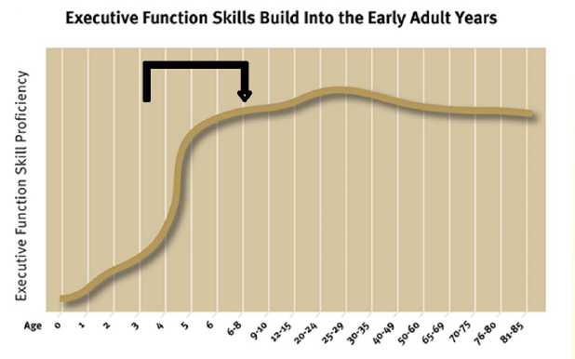  Teaching phonics is more effective on average than other approaches to early reading (such as whole language or alphabetic approaches), though it should be emphasised that  effective phonics techniques are usually embedded in a rich literacy environment for early readers and are only one part of a successful literacy strategy. We also embed strategies such as time to talk through school as well.  https://educationendowmentfoundation.org.uk/evidence-summaries/teaching-learning-toolkit/ this identifies the impact wider strategies have on educational attainment. | 1/2/4

Targeted academic support (for example, tutoring, one-to-one support, structured interventions)
Budgeted cost: £ 14,407
Activity | Evidence that supports this approach | Challenge number(s) addressed
Writing intervention  £7,640 | Again we use the principles of Rosenshine for our Writing interventions.  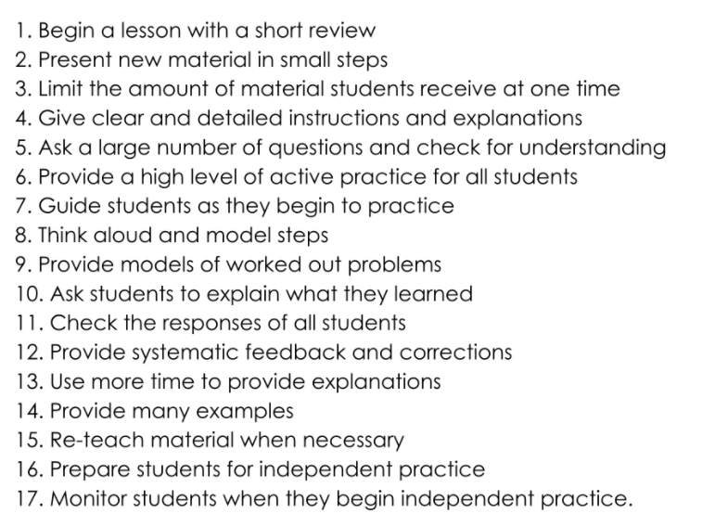  - Targeted support within classes  - In Y2 2 days of additional teacher input with smaller groups in writing sessions. | 1/2/4
Lexia  350 | Targeted reading and phonic support- research project | 1/2
Structured interventions- TA, specific to individuals  £6,417 | Inclusion meetings discussing impact each half term , analysing data to move children to ARE or GD | 1/2/4

Wider strategies (for example, related to attendance, behaviour, wellbeing)
Budgeted cost: £ 2,143
Activity | Evidence that supports this approach | Challenge number(s) addressed
Mental Health Support from Educational Mental health Practitioner  Cost of TA2 to support EMHP  £491 | We have a mental health practitioner who supports the school every Wednesday He uses the Healthy minds resources which have come from CAHMS directly.  He uses age appropriate emotional literacy support for different year group.  Autumn 1 - Year 1  Autumn 2 Year 2  Spring 1 Year 1  https://educationendowmentfoundation.org.uk/projects-and-evaluation/projects/developing-healthy-minds-in-teenagers | 3
uniform  £50.00 x 1 | Each child who is PP has an allowance of £50 to help with uniform costs.  https://www.tandfonline.com/doi/full/10.1080/19404476.2020.1759298 | 3
Personal well being materials  £400 | Each class has a turn around box to support emotional regulation. We also have a range of books to support different subjects such as bereavement. | 3
After school clubs  £1,202 | Children in receipt of Pp can access 1 club per term  Children who frequently participate in after school activities are more likely to show greater levels of attention in class, be more engaged in school, and are less likely to develop an inclination for antisocial and or problem behaviour.” Physical and Mental health benefits of after school clubs, http://www.aspiretogreatness.co.uk/physical-mental-health-benefits-of-after-school-clubs | 3

Total budgeted cost: £18,320
Part B: Review of the previous academic year

Outcomes for disadvantaged pupils
We have analysed the performance of our school’s disadvantaged pupils during the 2022-23 academic year using EYFS/ key stage 1 performance data, phonics check results and our own internal assessments.
Our results trend reflect the fact that a much higher % of pupils who are in receipt of PP / PP+ have identified Send needs . Currently 50% of children who are PP /PP+ had SEND compared to 20% of Y2 and 13% in the school as a whole.
Data was a follows in 2023 KS1 SAT’s ( 4 children)
ARE | Reading | Writing | Maths
National | 69% | 61% | 72%
Y2 DIS | 85.6% | 80% | 92.2%
Y2 DIS Children who were PP/PP+ (4 children, all children without SEND achieved ARE) | 75% | 75% | 75%

GD | Reading | Writing | Maths
National | 19% | 8% | 16%
Y2 DIS | 53.3% | 25.6% | 37.8%
Y2 DIS Children who were PP/PP+ | 50% | 25% | 50%
Where children do not have SEND they achieve ARE or GD. E.g. One of the 4 children started KS1 WT and ended up GD in two areas.

Externally provided programmes
Please include the names of any non-DfE programmes that you used your pupil premium (or recovery premium) to fund in the previous academic year.
Programme | Provider
RWI | Ruth Miskin
Lexia | Rosetta stone company

Service pupil premium funding (optional)
For schools that receive this funding, you may wish to provide the following information: How our service pupil premium allocation was spent last academic year
Ta small group work
The impact of that spending on service pupil premium eligible pupils
Individualised accelerated progress.

Further information (optional)
All children who are PP but don’t have send so have a review are offered a structured conversation in the autumn and spring terms. This means they get a 30 minute parent consultation in line with the principles of assessment for all.
We also prioritize children who need access to mental health support for time with our, mental health practitioner who works is based at the school one day a week.

