Dobcroft Infant School

‘To provide a foundation for fulfilled lives, inspiring confident and happy learners’
Our Values | Enjoy learning | Try our best | Make good choices | Respect each other & our surroundings | Work together | Celebrate our successes
 | 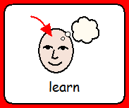 |  |  | 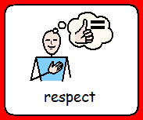 | 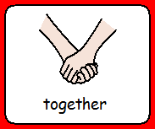

Equality Information & Objectives Statement
Sept 2023- December 2026

Document Adopted By Governing Body

Signed (Chair):
Date: | Sept 2023
Print Name: | Alice MacGowan
Date of Next Review: | September 2026

The Importance of Geography

Written by Juliet Murray

Our School

Dobcroft infant is committed to creating an inclusive community in which children and adults treat each other with respect and consideration so that everyone can learn, achieve and be successful. We actively strive to create an ethos and environment supportive of learning and emotional health and well-being. We focus on the well-being and progress of every child and where all members of our community are of equal worth.

Through our work we aim to ensure that all children treat others with respect, tolerance and kindness regardless of faith, ethnicity, gender, sex, age, disability, gender reassignment and other protected characteristics. Diversity will be understood, celebrated, and welcomed.

We believe that the Equality Act provides a framework to support our commitment to valuing diversity, tackling discrimination, promoting equality and fostering good relationships between people. It also ensures that we continue to tackle issues of disadvantage and underachievement of different groups.
We welcome our duties under the Equality Act 2010. The school’s general duties, with regards to equality are:

Eliminating discrimination.
Eliminate unlawful discrimination, harassment, victimisation and any other conduct prohibited by the Equality Act 2010

Fostering good relationships.
Foster good relations between people who share a protected characteristic and people who do not share it.

Advancing equality of opportunity.
Advance equality of opportunity between people who share a protected characteristic and people who do not share it

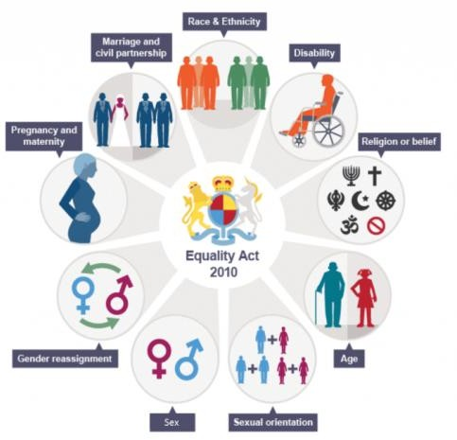
We will not discriminate against, harass or victimise any pupil, prospective pupil, or other member of the school community because of their:

- Sex.
- Age.
- Race.
- Disability.
- Religion or belief.
- Sexual orientation.
- Gender reassignment.
- Pregnancy or maternity.
- Marriage and civil partnership.

We aim to promote pupils’ spiritual, moral, social and cultural development, with special emphasis on promoting equality and diversity, and eradicating prejudicial incidents for pupils and staff. Our school is committed to not only eliminating discrimination, but also increasing understanding and appreciation for diversity.

Aims to eradicate discrimination

We believe that a greater level of success from pupils and staff can be achieved by realising the uniqueness of individuals. Creating a prejudice-free environment where individuals feel confident and at ease is a commitment of the school.

Our approach to equality is based on the following key principles:

- Inclusion is at the heart of all of our work
- We are respectful.
- We treat all members of the school community fairly.
- Developing an understanding of diversity and the benefits it can have.
- We foster positive attitudes and relationships and a shared sense of cohesion and belonging.
- We have created an inclusive curriculum that is accessible to all.
- We encourage compassion and open-mindedness.
- We actively promote the advancement of opportunity of all
- We aim to reduce and remove inequalities and barriers that already exist.
- We have the highest expectations of ourselves, and all our children.
- We listen to the concerns of all members of the community and responding appropriately and swiftly.
- We observe good equalities practice in staff recruitment, retention and development.
- We offer high quality education for everyone in a confident environment, in which all faiths and beliefs are valued and respected
- We promote an ordered and caring school environment where children, staff, carers and parents demonstrate the highest standards of personal conduct and where children enjoy high levels of confidence and self-esteem
- We encourage the active contribution of families and the local community to the life of our school and value the close partnership between school, church and home
- We adopt an inclusive attitude and ensuring that the whole school community understands what inclusive behaviour looks like in the school and how this aligns with the school’s values.
- We adopt an inclusive curriculum that is accessible to all.
- We challenge bias and calling it out in order to move the conversation forward.

We are committed to having a balanced, diverse and fair curriculum. We believe that our pupils should be exposed to ideas and concepts that may challenge their understanding, to help ensure that pupils learn to become more accepting and inclusive of others. Challenging and controversial concepts will be delivered in a way that prevents discrimination and promotes inclusive attitudes.

Dealing with prejudice and Celebrating Diversity

At Dobcroft Infant School we have clear policies and procedures in place for dealing with prejudice-related incidents. We do not tolerate any form of prejudice-related incident. Whether direct or indirect, we treat discrimination against all members of our school with the utmost severity. When an incident is reported, our school is devoted to ensuring appropriate action is taken and a resolution is put into place which is both fair and firm.
Related policies include:
- Relationships and Behaviour Policy
- Anti-bullying policy
- Safeguarding policy
- RSHE policy
- Attendance policy
- Code of Conduct
- Whistleblowing policy

School Values

Our School Values are consistently shared with all members of the school community:

Our Vision | To provide a foundation for fulfilled lives, inspiring and creating confident learners.
Our Values | Enjoy learning  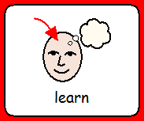 | Try our best | Make good choices | Respect each other & surroundings  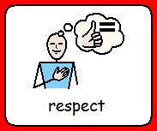 | Work together  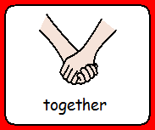 | Celebrate our successes

Our pupils are taught to be:
- Understanding of others.
- Celebratory of diversity.
- Eager to reach their full potential.
- Inclusive.
- Aware of what constitutes discriminatory behaviour.
The school’s employees will not:
- Discriminate against any member of the school community.
- Treat other members of the school community unfairly.
The school’s employees will:
- Promote diversity and equality.
- Encourage and adopt an inclusive attitude.
- Lead by example.
- Seek training if they need to improve their knowledge in a particular area.
Throughout the year, the school provides a variety of opportunities to celebrate diversity, including:
- RHE assemblies have a focus on celebrating diversity.
- Books and materials used to teach the curriculum and those that are available to children in the school’s provision celebrate diversity.
- Inviting guest speakers to talk to pupils about diversity.
- Incorporating lessons about diversity into the curriculum.

Equality and dignity in the workplace
Dobcroft infant is an Equal Opportunities Employer and is committed to eliminating discrimination and encouraging cultural diversity amongst its workforce. Dobcroft infant ensures that each employee feels respected. Eliminating discrimination helps everyone to have an equal opportunity to work and to develop their skills.
All employees of Dobcroft infant will be treated fairly and equally and will not be discriminated against on the basis of any of the following protected characteristics:
- Age.
- Disability.
- Gender reassignment.
- Marital or civil partner status.
- Pregnancy or maternity.
- Race.
- Religion or belief.
- Sex.
- Sexual orientation.

Equality of opportunity and non-discrimination extends to the treatment of all members of the school community. All staff members are obliged to act in accordance will the school’s various policies relating to equality.

We will guarantee that no redundancy is the result of direct or indirect prejudice. All disciplinary procedures are non- prejudicial, whether they result in warnings, dismissal, or any other disciplinary action.

Diversity, Representation and Inclusion

Dobcroft infant will work to ensure no employee experiences discrimination, victimisation or harassment. Where there are incidents, these will be responded to quickly and appropriately.

Direct discrimination – Dobcroft infant employees will not be directly discriminated against. Direct discrimination occurs when someone is treated less favourably because of a protected characteristic they have or are thought to have, or because they associate with someone who has a protected characteristic
Discrimination by association – Dobcroft infant employees will not be discriminated against by association. Discrimination by association is direct discrimination against someone because they associate with another person who possesses a protected characteristic
Perception discrimination – Dobcroft infant employees will not receive perception discrimination. Perception Discrimination is direct discrimination against an individual because others ‘think’ they possess a particular protected characteristic. It applies even if the person does not actually possess that characteristic
Indirect discrimination – Dobcroft infant employees will not suffer indirect discrimination. Dobcroft infant policies, practices, rules and procedures will be fair and will not disadvantage people who share a protected characteristic. In some circumstances indirect discrimination can be justified if it is ‘a proportionate means of achieving a legitimate aim’.
Harassment - Harassment is unwanted conduct related to a relevant protected characteristic, which has the purpose or effect of violating an individual’s dignity or creating an intimidating, hostile, degrading, humiliating or offensive environment for that individual. Dobcroft infant employees should also not suffer from harassment because of perception or association. Managers should deal appropriately with instances of harassment and discuss with Human Resources if needed.
Third party harassment - As far as reasonably possible the Dobcroft Infant School will ensure its employees do not suffer any form of harassment from third parties who are not employees of the organisation, i.e. customers or clients. If an employee is known to have received or has reported receiving harassment from a third party, the employee’s Manager will need to ensure reasonable steps are taken to prevent it from happening again.

Victimisation – Dobcroft Infant employees will not suffer victimisation. Victimisation occurs when an employee is treated badly because they have made or supported a complaint or raised a grievance under the Equality Act; or because they are suspected of doing so.

Closing Statement

At Dobcroft infant we aim for all of our community to feel supported and valued. We educate children through our curriculum, about the importance of the protected characteristics, equalities and the values of tolerance and respect.

We recognise the importance of quickly and appropriately responding to any concerns related to the promotion of the equality act and want to work proactively with our school community.
Prejudice is not tolerated and we are continuously working towards a more accepting and respectful environment for our school community.

Equality information December 2023
Pupils
Category | No | %
Males | 171 | 57%
Females | 129 | 43%
Other Asian Background | 5 | 1.67%
Bangladeshi | 5 | 1.67%
Indian | 8 | 2.68%
Pakistani | 15 | 5.02%
Other Black African | 1 | 0.33%
Chinese | 3 | 1.10%
White and Black African | 0 | 0.00%
Any other mixed background | 8 | 2.68%
White and Black Caribbean | 4 | 1.33%
White and Pakistani | 2 | 0.66%
White + any other Asian Background | 10 | 3.33%
Refused | 3 | 1.10%
White Eastern European | 0 | 0.00%
White – British | 224 | 74.92%
White other | 8 | 2.68%
Traveller of Irish Heritage | 3 | 1.10%
Free School Meal Children | 5 | 1.67%
English as an additional language | 63 | 21.0%
Pupil Premium | 5 | 1.67%
Special Educational Needs Pupils | 40 | 13.33%

School Staff

Category | No | %
Males | 4 | 7%
Females | 46 | 93%
White British | 40 | 81%
Asian or Asian British, Pakistani | 3 | 5%
Mixed White and Asian | 1 | 2%
Any other ethnic background | 1 | 2%
Mixed white and black Caribbean | 2 | 4%
White & any other white background | 1 | 2%
Asian or Asian British, Indian | 1 | 2%
Staff member with a disability | 1 | 2%

