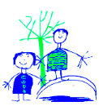Dobcroft Infant School

‘To provide a foundation for fulfilled lives, inspiring confident and happy learners’
Our Values | Enjoy learning | Try our best | Make good choices | Respect each other & our surroundings | Work together | Celebrate our successes
 | 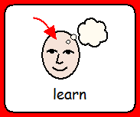 | 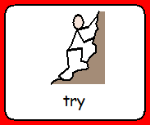 | 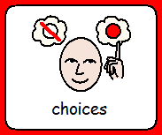 | 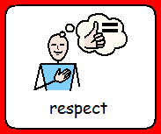 | 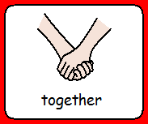

Relationships and Behaviour Policy

Document Adopted By Governing Body

Signed (Chair):
Date: | Sept 2023
Print Name: | - McGowan
Date of Next Review: | Sept 2024

Introduction

Our school is committed to creating an inclusive community in which children and adults treat each other with respect and consideration so that everyone can learn, achieve and be successful. We actively strive to create an ethos and environment supportive of learning and emotional health and well-being. We teach our children social and emotional skills (SEAL and RHE) to help them to recognise and understand their own feelings and to take responsibility for their own behaviour choices.

Dobcroft Infant School’s vision statement is “To provide a foundation for fulfilled lives, inspiring confident and happy learners”.

Our School Vision applies to everyone and was negotiated with children, governors, staff and parents. It helps to create a respectful, safe and thriving learning community. The school values uphold the school vision.

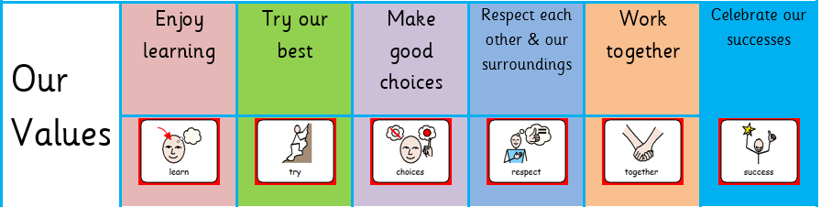

Our school relationships and behaviour policy is underpinned by these 6 values. They are displayed throughout the school and in every classroom. We remind the children that these are the key values that we follow to keep our school a safe and happy place.

This policy is designed to promote a positive ethos of good behaviour in which children can work and play well together with other people. There is a high expectation of behaviour in all aspects of the school day which places the needs of the child at its centre.

Our school will support all children including those displaying social, emotional and mental health (SEMH) difficulties. We maintain the belief that pupils’ behaviour should be understood and can be modified, managed and enhanced in order to enable them to access learning.

We teach our children to take responsibility for their behaviour choices. We try to ‘put things right’ when our behaviour causes others hurt, disadvantage or disrupts learning.

Encouraging behaviour for effective learning is the responsibility of everyone in school. We will do this by:

- Consistent Trauma Informed approach to behaviour
- Offering stimulating teaching which invites children to engage and participate actively
- Celebrating effort, achievement and attainment
- Having clear and consistent high expectations of behaviour
- Using consistent whole school, behaviour management strategies and teaching of good behaviour
- Creating and sustaining a high quality school environment
- Acting as positive role models in our own relationships with children, parents and staff
- Working with parents to share our behaviour strategies
- Encouraging children to make good choices and take responsibility for their own self-discipline
- Helping children to use a restorative approach (putting it right)
- Teaching the qualities of learning: The 5Rs (Resourcefulness, Resilience, Reciprocity, Risk-Taking, Reflectiveness)
- Providing additional social and emotional learning support for vulnerable pupils
- Monitoring rates and patterns of behaviour which impedes learning
- Take into account the whole child when dealing with behaviour, including anything which may affect behaviour such as SEN needs or early childhood experiences.

Trauma Informed Approach
Staff have undertaken training programmes through TISUK.

This means that we:
- Place relationships and a child’s sense of safety and security at the heart of the classroom management
- Encourage nurture, warmth and empathy when a child or young person is presenting with behaviours
- Promote a sense of community and belonging
- Take individual circumstances into account

In practice this means that we:
- Identify and meet the need being communicated through behaviour at the earliest opportunity (rather than giving sanctions for behaviour)
- Have restorative conversations between the child and an emotionally available adult (EAA) at a point where the child is calm enough to reflect on triggers, thoughts, feelings and what might help them in the future.
- Use a relational approach to behaviour management. A relational approach is one in which staff “are aware of and explicitly focus on the quality of their interactions with children to develop classroom communities that promote academic, social and emotional growth. This will still include discussing consequences and using problem solving skills as opportunities to learning.
- Recognise, validate and attune to children and this takes precedence over other means of discipline – “Connection before Correction”
- Focus on the function behind the behaviour rather than the behaviour itself.

To this end our school is committed to educational practices promoted by TISUK: Protect, Relate, Regulate and Reflect:

Protect
Increased ‘safety cues’ in all aspects of the school day; ‘meet and greet’ at the classroom door and an open-door policy for informal discussions with parents/ carers. Staff trained in ‘PACE’ modes of interaction (Dan Hughes); being warm emphatic, playful and curious (proven to shift children out of flight/fright/freeze positions).
Staff ensure that interactions with children are socially engaging and not socially defensive, to decrease likelihood of children relating defensively (flight/fright/freeze). Pedagogic interventions that help staff to get to know children better on an individual basis e.g. Time to Talk and ‘I wish my teacher knew’. This is key to enabling children to feel safe enough to talk, if they wish, about painful life experiences, which are interfering with their ability to learn and their quality of life.
Vulnerable children have access to an emotionally available adult, and know when and where to find that adult.
School staff adjust expectations around vulnerable children to correspond with their developmental capabilities and experience of traumatic stress. This includes removing vulnerable and traumatised children in a kind and non-judgmental way from situations they are not managing well (e.g. children who are continually triggered into alarm states in the main playground can access calmer, smaller areas with emotionally regulating adults).
Relate
A whole-school commitment to enabling children to see themselves, their relationships and the world positively, rather than through a lens of threat, danger or self-blame. Vulnerable children provided with repeated relational opportunities (with emotionally available adults) to make the shift from ‘blocked trust’ (not feeling psychologically safe with anyone) to trust, and from self-help to ‘help seeking’. An example of a strategy employed throughout school to support this is Time to Talk.
Regulate
Relational interventions specifically designed to bring down stress hormone levels (e.g. from toxic to tolerable) in vulnerable children, enabling them to feel calm, soothed and safe. This is to support learning, quality of life and protect against stress-induced physical and mental illness, now and in later life. Evidence-based interventions that aim to repair psychological damage and brain damage caused by traumatic life experiences, through emotionally regulating, playful, enriched adult-child interactions.
Reflect
Staff training and development in the art of good listening, dialogue, empathy and understanding is provided regularly. This means that a trusted relationship with a member of staff can be established so that children can reflect on what has happened be given the opportunity to understand their behaviour. An example of a strategy employed throughout school to support this is “Put it Right” area.

PSHE (Personal, Social and Health Education)
Social and Emotional Aspects of Learning (SEAL) underpins our approach to promoting positive behaviour for learning in The Foundation Stage while children in KS1 have a dedicated RHE (relationship and health education) curriculum. All children learn about the link between feelings, thoughts and behaviours. We teach our children how to recognise, name and manage the powerful feelings that can sometimes overwhelm them and lead to behaviours that impede learning and fulfilment. We also practise calming down tricks so that we are prepared for effective learning. Our curriculum fully complies with statutory guidance and has been through consultation with our school community and a parent focus group (Nov 2021).

Behaviour Strategies and the Teaching of Good Behaviour
The teaching of good behaviour represents an opportunity to teach, nurture, provide boundaries and problem solve. “It is important to reflect on the function behind the behaviour, the lesson that should be taught and the best way to teach that lesson” (The Yes Brain Child, Siegel & Bryson, 2018). Trauma informed approaches to behaviour aim to understand what a child might be trying to say to us through their behaviour. Behaviour that challenges is not seen as a choice, but as being a communication of an unmet need. Staff using a trauma informed approach strive to understand the function behind a behaviour.
Consistent expectations of behaviour are essential for pupils to understand what is expected of them and to avoid mixed messages.
We foster a restorative justice approaches which enable pupils to reflect upon their behaviour and to make amends. Some children benefit from having the opportunity to co-construct ideas for repairing a situation, alongside an adult. An emphasis is placed on restoration, not punishment or blame, and should aim to reduce feelings of guilt in the child.
Whilst consistency of approach is important for children and young people to feel safe and secure, it is also important to differentiate expectations and approach according to a child’s abilities, needs and experiences. Whilst the majority of children will thrive when a whole school approach to behaviour is applied, some will need further support and intervention, and a few will require more intensive, individualised support.
All of our staff undergo termly Trauma Informed training and key information including adverse child experiences (ACES) and external factors are shared promptly with relevant staff. All of our staff understand that presented behaviour can be an outcome or a response to ACES and will adopt and implement trauma-informed strategies that pre-empt unacceptable behaviour.

We encourage good behaviour through communication of our School Values and the 5Rs. Expectations and routines are explicitly taught to the children to ensure consistency of approach. The school values and 5Rs are clearly displayed in every classroom and around the building in communal spaces. Staff reinforce these displays by drawing attention to them daily as part of their classroom management strategies.

It is recognised that good behaviour needs to be modelled and taught. We embed the PACE (Play, Acceptance, Curiosity, Empathy) approach originated by Hughes in order to support a child’s social engagement system. The development of positive pupil/staff relationships along with effective teaching which recognises individual needs encourages children to behave in appropriate and less challenging ways.

Staff use a range of strategies as described in this policy which allow pupils to learn how to manage their emotions more effectively without disrupting the learning of others.

These strategies may include:
● Time alone in another part of the classroom with an EAA nearby
● Support with an emotional available adult
● Use of a turnaround box
● Use of the Put It Right Area with an EAA or alone if appropriate
● Use of time away from the classroom with an EAA or alone if appropriate, for example in a calm area such as The Hive, Butterfly Room or Forest School.

Our school’s expectations about behaviour also apply to all off-site activities, educational visits and whilst children are being transported.

Time To Talk: From day one at Dobcroft Infant School, children have “Time To Talk”, where adults model expected behaviour in-the-moment and support children to establish and practise strategies that help them to meet our school values. This establishes strong relationships between pupils and staff, providing secure attachments and trusting relationships. This reinforces the educational practices of Protect.

Team Teach: Staff are trained in Team Teach and are expected to employ the Team Teach principles to meet the following objectives (taken from the Team Teach website):
- recognising the importance of and using de-escalation techniques and working as a team when managing challenging behaviours.
- applying an understanding of the legal implications of positively handling.
- using a gradual and graded response to managing challenging behaviours and the use of positive handling as a last resort option.
- by applying an increased awareness of the need for documentation for the recording and reporting of incidents.
- using active listening skills and participating in a process of debriefing, repair and reflection.

Put it Right
Each classroom has a designated Put It Right area. This reinforces the educational practices of Relate, Regulate and Reflect. The children are expected to take an active role in recognising their choices and understanding the effect they have on others. They are expected to try to ‘Put It Right’. In Foundation Stage this will be supported by an emotionally available adult who will model expectations, by Year Two children can access this area independently to resolve conflict independently.

The 5 Rs
During curriculum time, practitioners and classmates spotlight the 5Rs of learning: resourcefulness, reciprocity, reflectiveness, resilience and risk-taking.
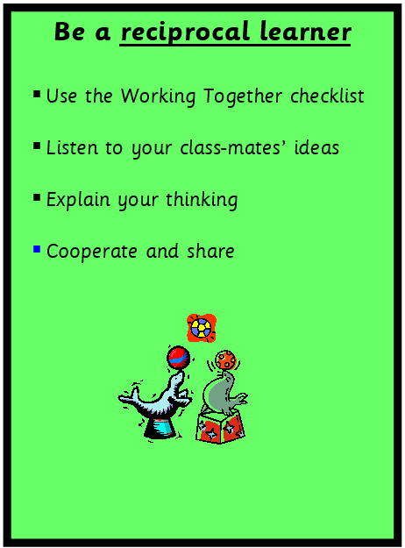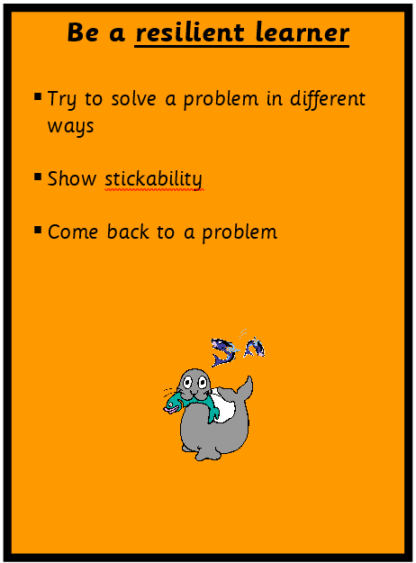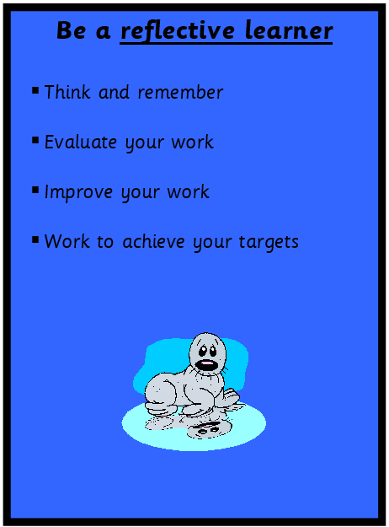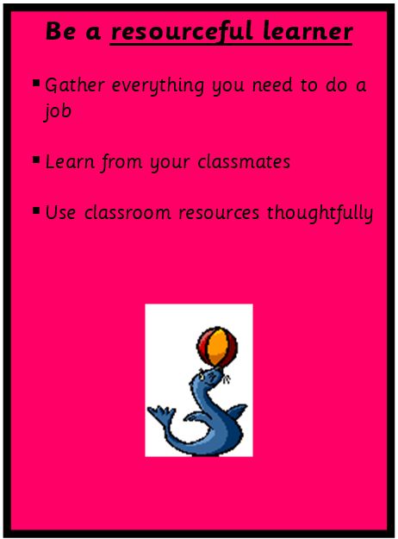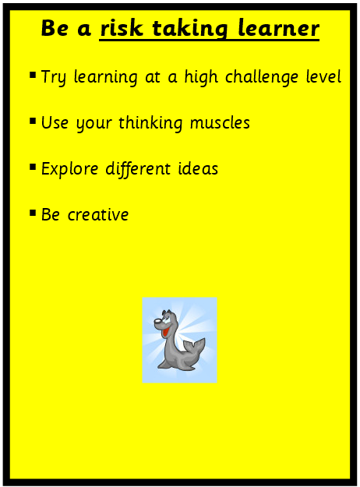
These link very closely with our school values. This has a positive impact on behaviour as the children are consistently taught the link between making good behaviour choices and effective learning. They are expected and helped to work together, to take responsibility for their own behaviour and to acknowledge the consequences of their actions.

Zones Of Regulation
We want to support all children at our school to feel happy and enjoy their learning. We use ‘Zones of Regulation’ to help the children understand and voice the emotions they feel, and to find ways to manage big emotions such as anger and frustration. We have regular emotional check-ins with the children. We also use brain breaks, mindfulness and a focus on the outdoors to help the children stay regulated. We are linked to the healthy minds project and have an Educational Mental Health Practitioner (EMHP), who visits us weekly to work with individuals, families and small groups of children to build self-esteem and teach children strategies to help their manage their emotions.

Consistency & Leadership
Consistent yet flexible implementation of this policy by all is vital, to consider the varied and complex needs of the pupils who attend our school. Leadership promote regular attendance, a good work ethic, self-discipline and respect for others.

To help us achieve this we will:
- Ensure all children and adults know and understand the school values, rewards and consequences through consultation with staff, children and parents;
- publicise the above so that everyone is clear about what is expected and approaches to behaviour management are consistent across the school;
- ensure a trauma-informed approach is embedded across the school so that the mental health and wellbeing of pupils and staff is a priority;
- ensure that children understand the meaning of inappropriate and unsafe behaviour and bullying and know how the school will deal with it.

Rights Respecting School
“Everyone within our school has the right to feel safe and secure”
“Our staff have a right to teach and work in a friendly, safe and satisfying school that is supported by the school community.”
“Our parents and carers have a right to feel welcome and to be included as partners in their child’s learning.”

We are a Rights Respecting School and have achieved the UNICEF Silver award. This means that we teach our children about the 42 Rights of the Child as underpinned by the UN Convention on the Rights of the Child (UNCRC). Our children understand that all children have a right to be heard, a right to learn and a right to be safe. Our Key Stage 1 Rights Respecting Council meet to share our class’ ideas and represent our school, and lead assemblies about charitable initiatives or school improvement plans.

Celebrating Successes
We regularly celebrate the success of all pupils in a variety of ways as we recognise that focussing on success and positive outcomes is essential in developing a positive culture and ethos. We celebrate these successes in many ways including:

Classroom Reward Systems
Each phase has its own themed behaviour prompt.
Children in The Foundation Stage collect bumble bees on a Sunflower and are rewarded with a whole class treat when they achieve their target. In addition individual children are rewarded through the class superstar chart.
Children in KS1 have a class Rainbow reward chart and are rewarded with stickers, stamps, certificates and prizes from a prize box. In addition, classes may also work as a team on a whole class focus e.g. marbles in a jar.
Class behaviour targets and rewards are negotiated and the children agree on a realistic number of times they will show the behaviour in the time period. If the target is met, the class is rewarded.

Golden Moments
Golden Moments are a way to reward wanted behaviours. Children in Key Stage One are rewarded for making good choices, in line with the school values, by staff in school giving them a golden moment. Each Key Stage One class will have a collection tin in their class in which they can place a gold star. The golden moments total for each class will be displayed in the assembly hall on a Friday. Children who have earned a golden moment during that week will be recognised with a round of applause during the Friday assembly. The class with most golden moments will sit on the bench during the next week’s assemblies in recognition of their achievement in collecting the highest number of golden moments. Children in the Foundation Stage visit assembly from the Summer Term. There is a focus given to the children each week based on the school values.

Celebrating achievements
We love to celebrate the children’s achievements both in and outside of school. We use class website pages and our school X (twitter) page to shout about our achievements. “Wow sheets”, completed by parents, show off great achievements outside school, and children are also given the opportunity to show their learning to the head teacher where they have shown behaviours that represent our school values and/or the 5Rs.
We also show the children’s learning in assembly. Assemblies have a strong focus on creating a caring, collaborative community. They are a forum for supporting our PSHE work and a time to promote and celebrate understanding, tolerance and an interest in the beliefs and culture of the whole community. We expect our children to walk quietly into assembly and to sit and listen to the calm background music. Assemblies are not passive. We encourage our children to listen, reflect, sing and to take turns in showing and explaining their ideas and work. Each week teachers nominate children who have shown positive behaviour for learning. The head teacher awards them a certificate for explaining their positive behaviour during assembly. We also have a weekly kindness award for both staff and students.

Outside Learning Times
Playtimes: Duty staff and Year Two Playground Leaders work together to ensure that all children enjoy a happy and safe playtime. The playground is zoned so that children are able to play football, play on the Heart Start Line, Trim Trail and Jungle Walk or enjoy a quieter time in the Hexagonal Garden or mud kitchen. At the end of playtime the duty staff or welfare supervisors blow the whistle to signal that the children should return to their classrooms. Teachers wait in the classrooms to greet the children and ensure all the children are present. Staff on duty remain in the playground to ensure all children have returned inside. Vulnerable children are collected separately and taken back to their classroom. This process ensures no learning time is lost and makes transition times calm and efficient.
Children and adults supporting on educational visits are given a parent/helper briefing which includes information about expectations of behaviour. There will be sufficient adults on these visits to allow 1:1 support if a child is not able to meet these expectations without it. The principles of this Relationships and Behaviour Policy would apply on all Educational visits.

Lunchtimes: Our Foundation children eat their lunch in the hall before the older children. Foundation Stage staff accompany the children into the dining hall to support them in making their hot dinner choice, locate their packed lunch box, manage collecting cutlery and finding a place to sit and eat.
We sometimes play music in the hall and allow children to sit with their friends so that the dining experience is a positive social time. Our Welfare Supervisors encourage the children to be well mannered and praise them for remembering to say please and thank you. The Welfare Supervisors identify children that they have observed consistently following the school values during the course of the week and reward them using the Golden Moments reward system.
Class teachers and Welfare Supervisors identify and monitor children who need support to enjoy safe and social times at lunchtimes or who find it difficult to eat their lunch. These children are recorded on the Observation Book in the staffroom and on CPOMS. The Welfare Supervisors meet daily before and after their duty starts to discuss roles and individual children. They also have regular meetings with the Deputy Head to discuss behaviour management. Some children need support to experience happy, safe lunchtime play. A Welfare Supervisor or teaching assistant is also available in the Butterfly Room to help children who need to calm down, review their behaviour choices or to talk through experiences during lunchtime.

Playground Leaders
The Year 2 children get the chance to volunteer to be a playground leader. These children play a really important role in supporting the other children to have happy and safe lunch times. They support children in the dining hall, help with friendship issues outside and are fantastic role models for the other children in the school.

Moving Around School
We all walk calmly and use our inside voices when moving about inside school. When moving around school, lining up for dinner and during tidy up times we teach our children to keep to their own personal bubble space. We expect children to have respectful interactions with the people they come into contact with.

Training and Communication
Staff Development & Support
The induction of new staff includes an introduction to our Relationships and Behaviour Policy. Staff briefings enables relevant information about children to be shared. Staff have opportunities to discuss difficulties within an open and non-judgemental framework. Regular staff meetings ensure consistency is achieved across the school.

Liaison with parents/carers and other agencies
Where necessary a behaviour plan may be set up to identify approaches to managing behaviours that are causing concern. Behaviour plans are developed in partnership with parents and relevant school staff. If parents need additional help then they can access The Family Intervention Service (FIS) through school or our EMHP. Parental support and engagement of our Relationships and Behaviour Policy is an important part of making positive changes for their child. Parents/carers are encouraged to contact our school whenever they need to with any concerns they may have, and are encouraged to be proactive in sharing and solving problems as they arise.

Monitoring & Review
It is the responsibility of all staff to incorporate, reinforce and model these expectations in their everyday work, their teaching of lessons and their interactions with pupils.
It is the responsibility of the Head Teacher and the Senior Leadership Team to lead, support and monitor the consistent implementation of this policy.
All staff monitor and record behaviour which impedes or disrupts learning. Staff record incidents on CPOMS. This is then reviewed by the SLT to monitor frequency and to look for patterns or triggers. Teachers have a half termly inclusion meeting with the Head Teacher and Deputy to discuss the learning and progress of each child. Factors which may result in adverse behaviour (e.g. health, changes in home circumstances, attitudes and dispositions, attendance and punctuality) are discussed. This enables vulnerable children to be identified and helped with targeted interventions. Classroom teachers will ensure that other staff e.g. PPA or supply teachers, welfare supervisors, TAs who work with the class are informed about any behavioural issues and that there is a consistency of approach. Welfare supervisors will be notified of significant vulnerable children, who may need additional support during lunch via a confidential welfare supervisor’s file and through CPOMS.
This policy is subject to annual review by the full governor board. SLT also liaise with the Link Governor for relationship and behaviour.

Bullying
Everyone has a right to learn in a safe school. We teach our children that bullying is always wrong and we do not tolerate it. Bullying is targeted, persistent behaviour which hurts, threatens or intimidates others. We encourage our children to tell an adult if they or others are being bullied. All members of our school community are taught to identify bullying behaviour and to be proactive in preventing and dealing with it. (See Anti-Bullying Policy). The Head Teacher reports the number of bullying incidents to Governors every term and reports annually to the LEA.
Each year children take part in Anti Bullying week and children are taught to recognise signs of bullying and how to respond if they are worried about bullying behaviour. During Anti Bullying week children may dress up in Blue (Be Lovely And Understanding To Everyone) or odd socks to celebrate our uniqueness and create a class anti bullying charter.

Links to other policies
This policy does not stand alone and should be read in conjunction with the staff Code of Conduct and the following school policies:
● Child protection & Safeguarding  ● Anti-Bullying  ● Suspension & Exclusion Policy  ● E-safety & Acceptable Use  ● Home-school agreement  ● SEND | ● Equality, Diversity & Cohesion  ● Attendance  ● Teaching & Learning  ● Off-Site Visits & Outdoor Education  ● Health and Safety  ● Physical Intervention  ● PSHE
Our Relationships and Behaviour Policy acknowledges the school’s legal duties under the Equality Act 2010 in respect of safeguarding and in respect of pupils with special educational needs (SEN).

