
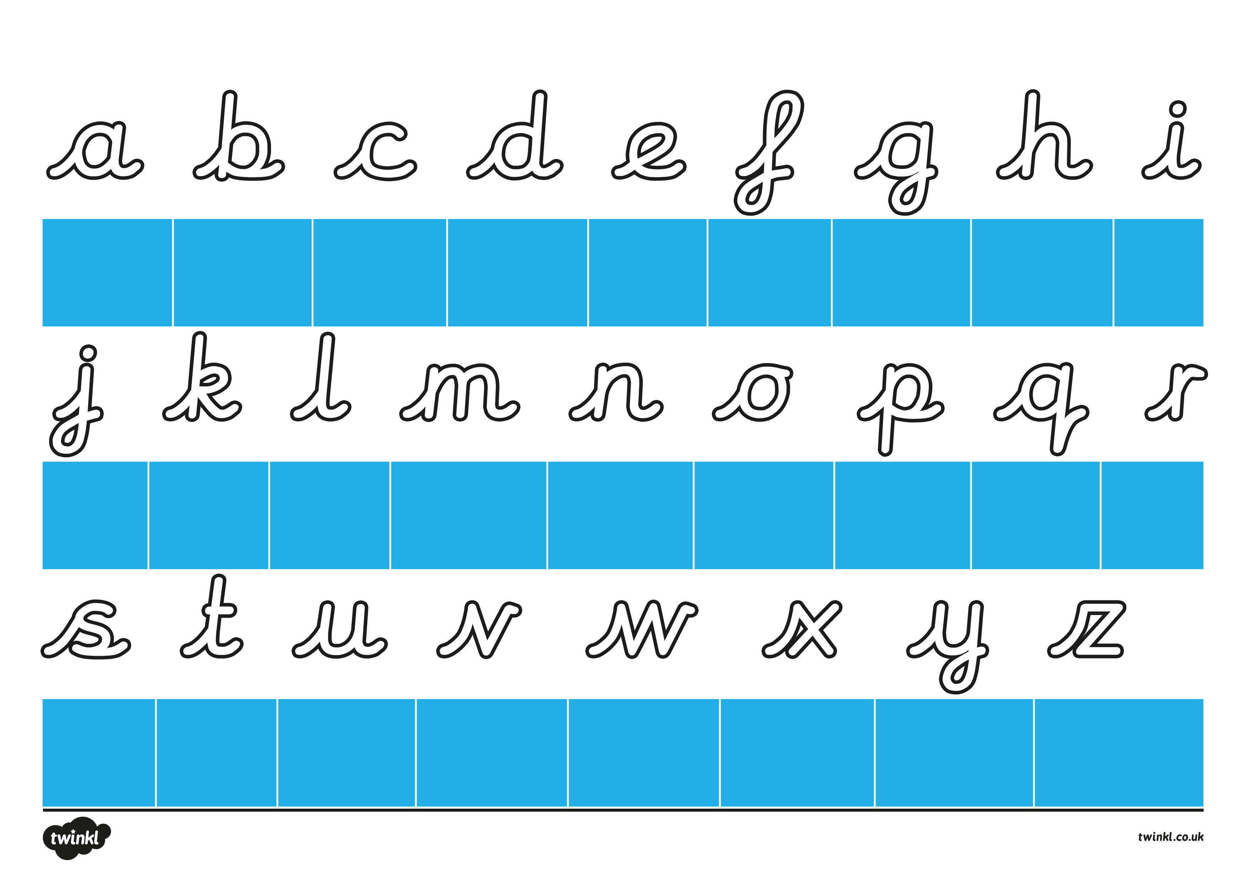
Whoosh in and round you go. Up, down and kick out a’s toe.
Whoosh in and up tall and back down. Then halfway up and all the way round. Add a lead at the end so b can join onto a friend.
Whoosh in and curl the c. C joins other letters easily.
Whoosh up halfway and go round. Then all the way up and back down. Kick out d’s toe, and she’s ready to go.
Whoosh in and curl like a snail and leave an easy joining tail.
Whoosh in to the top and go round and then zoom under the ground. Under the line, loop the last part and finish your f near its start.
Whoosh in, go round to the top. Go down under the line, loop and stop.
Whoosh in and up tall and then down. Halfway up, bend over and flick off the ground.
Whoosh up and down, then kick out a toe. Add a dot and I’s ready to go.
Whoosh up then zoom down under the line. Loop the tail then add your dot at the right time.
Whoosh up tall and back down. Go halfway up and around. Go down and out with a flick. Your k is ready to kick!
Whoosh in and up tall. Down to the ground and make your flick small.
Whoosh in and then down. Up, over and back to the ground. Up, over and down again. Add a flick to finish your m.
Whoosh in and then down. Up, over the hump and flick off the ground.
Whoosh in round you go. Lead out from the top for your o.
Whoosh in and then go down low. Back up to the top and round you go. Lead out at the end so that p can join onto a friend.
Whoosh in and round you go. Then zoom under the line and kick out q’s big toe.
Whoosh to the top to start. Go down and curve the top for your r.
Whoosh in and curl left. Curl right then lead out of your s.
Whoosh to the top and back down. Then add a flick off of the ground. You need to cross the t. With a straight line on his tummy.
Whoosh up then down. Bend round, go up and down to the ground. Kick out a toe and u is ready to go.
Whoosh up then down into the valley. Zoom back up and across the top to finish your v.
Whoosh in, then down and back up. Down again, up and across at the top.
Climb up to the top and then slide down from left to right and have a rest. Jump back to the top, go from right to left and you have an x!
Whoosh up then down and bend round. Go up then down underground. Loop the tail under the line. Lead the y out and it’s looking fine!
Whoosh up then to the right. Zig zag down and back to the right.
Letter Formation Handwriting Sheet with Rhymes

