Number of Sea Creatures | 8
 | 7
 | 6
 | 5
 | 4
 | 3
 | 2
 | 1
 |  | 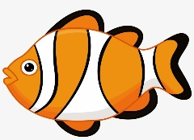 |  |  | 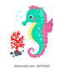
Type of sea Creature

