The Great Big School Clean 2021
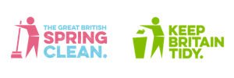

JOIN THE GREAT BIG SCHOOL CLEAN 2021!
Spring is finally here and Keep Britain Tidy and Eco-Schools need your help to take a stand against litter! You can help by joining our #MillionMileMission for the Great Big School Clean 2021!
This spring the Great Big School Clean is attempting to complete a colossal million miles of litter-picking… that’s to the moon and back, twice! We are asking all participating schools to simply record the number of litter-pickers taking part and the hours and minutes they plan to spend litter-picking. Then, we will do the rest - using a slow walking pace of three miles per hour we will calculate how many miles you have pledged towards our #MillionMileMission!
The Great Big School Clean will take place from 28 May – 13 June 2021, and the great news for schools is that any clean-ups you register from now until the 13th June will be counted towards our total.
It only takes a minute to let us know you are taking part, and you can even forward the link to your school community to encourage individual pledges!
Thanks for making a difference,
PLEDGE TO TAKE PART NOW!

