Dobcroft Infant Y2 Autumn Term Curriculum News

This term, our whole school theme is Houses and Homes. Each class will embark on a learning journey based on the children’s questions and our new curriculum objectives. Our first half term will have a science focus and we will be learning about animals and their habitats. In the second half term we will have a history focus. We will be learning about the Victorians and the lives of people of Sheffield in the past. In assembly time, we will learn songs connected with houses and homes. Speakers and trips will be connected to the theme and will help to enrich the children’s learning.

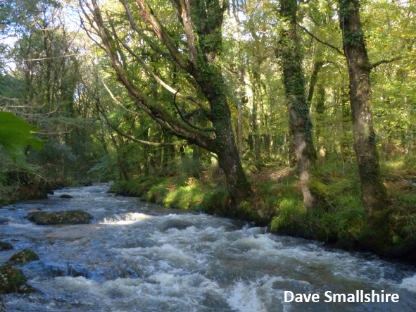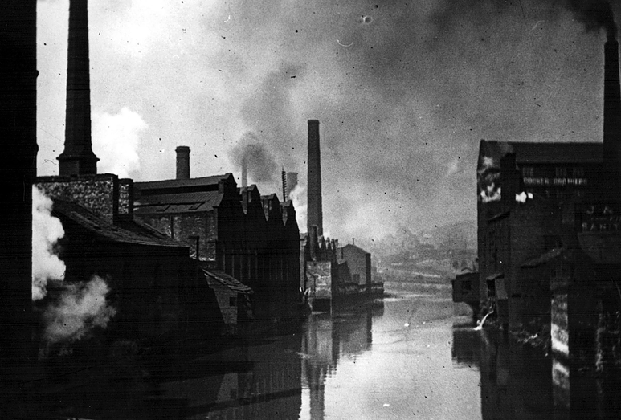

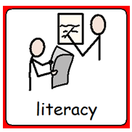
English

In English each half term we will focus on one text. This half term our book is “The Owl Who Was Afraid of the Dark”. Next half term we will read an abridged version of “Oliver”. As writers, we will: Write for different purposes and audiences in a range of genres, e.g: lists, postcards, letters, diary entries, recounts, instructions, explanations, non-chronological reports, stories, poems, plays. Think Out Loud before we write. Proof read to check for meaning and SPaG (spelling, punctuation and grammar) errors. Read our writing aloud. As readers, we will: Efficiently find information in non-fiction books. Improve our vocabularies by using a thesaurus and discussing our favourite phrases. Listen to and recite poetry. Predict what might happen using clues from the text. Compare stories by the same and different authors. Discuss story themes. Recommend books and explain our preferences. We will work in our Read Write Inc (RWI) group three times a week. We will: use the 44 sounds to read words using sound blending, read lively stories featuring words we have learned to sound out, answer 'Find It' and 'Prove It' discussion questions and write using the exciting vocabulary we have learned. We will also be focusing on the common exception words for our weekly spellings. The teachers will assess our phonics skills every six to eight weeks and move groups accordingly.
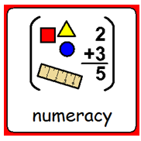
Mathematics

As mathematicians, we will: Deepen our understanding of the number system, including place value and ordering and comparing numbers up to 100. Count in steps of 2, 3, and 5 from 0 and in tens from any number, forward and backward. Read and write numbers to at least 100 in numerals and in words. Remember addition and subtraction facts to 20 fluently then to 100. Solve problems with addition and subtraction. Estimate and measure to the nearest appropriate unit:rulers (m/cm) for length/height, scales for mass (kg/g) and measuring vessels for capacity (ml/l). Tell and write the time to five minutes, including quarter past/to the hour. Compare and sort 2-D and 3-D shapes and everyday objects. Describe position, direction and movement. Apply our knowledge to different contexts to deepen our understanding.
Creative Development

As designers we will design, make and evaluate puppets and use our joining skills create a replica Victorian village.

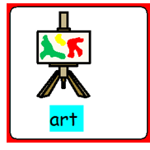
As artists, we will: Draw, paint and sculpt to develop and share our ideas, experiences and imagination. Learn how to use colour, pattern, texture, line, shape, form and space.
Create art work based on our science learning using materials found from our local habitat.

As musicians, we will: learn to use our voices expressively and creatively by singing songs linked to our houses and homes theme, including some of the songs from Oliver. The Woodpeckers and Owls will start their violin lessons. The Kingfishers will start their violin lessons after February half term.

Knowledge and Understanding of the World

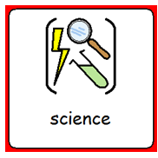
As scientists, we will: Explore life processes, beginning with examining what is alive and not; asking how we keep living things alive and noting changes that occur over time. Compare animal habitats and develop ideas as to why and how animals adapt to different living conditions.

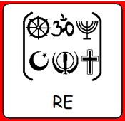
In Religious Education, we will find out about and discuss: People’s beliefs about God, humanity and the natural world. (Christianity, Islam and non-religious). Special stories. The importance of celebrations and symbols. What makes some teachers and leaders special for religious people? We will visit the local mosque.

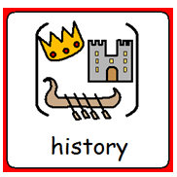
As historians, we will find out about life in Sheffield in the Victorian times. We will study the lives of significant people past and present and make comparisons.

In computing, we will learn: how to use technology safely and respectfully, keeping our personal information private. Learn about algorithms and how they program digital devices. Write our own clear, precise algorithms and debug ambiguous instructions.

In Global Education, we will learn about The Rights of the Child; the right to have safe drinking water and how rich countries can help poorer countries achieve this. We will find out about the effects of greenhouse gasses on the climate and how we can adapt to the changes that are happening e.g. flooding and water shortage.

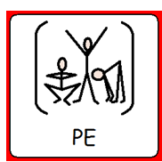
As gymnasts, dancers and athletes, we will: Take part in co-operative and competitive PE. Improve our running, jumping, throwing and catching. Improve our balance, co-ordination and agility. Use attacking and defending tactics in team games. Perform dances using simple movement patterns.
computing
Personal, Social and Emotional Development

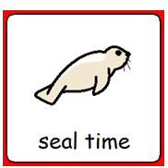
Social and Emotional Aspects of Learning (SEAL)
In the first half term, our SEAL theme is New Beginnings. We will explore how to make our classroom and school a safe and fair place for everyone and how to calm ourselves when we feel scared or upset. In the second half of the term, our Getting On and Falling Out theme explores: Friendship and compliments, managing angry feelings, Seeing things from another point of view and Resolving conflict by using the Put It Right area in the classroom.

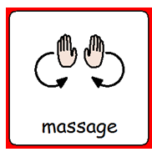
During SEAL time, we learn about ‘Calming Down Tricks’ and use different relaxation techniques to prepare us for learning. We use peer massage and teach the Massage In Schools Programme. Peer massage is given and received with the child’s permission. The children learn a set routine of strokes and massage each other’s heads, necks and arms. There are many benefits to peer massage including: calmness and improved concentration, increased confidence and self-esteem, respect for others and improved emotional health and motor skills.
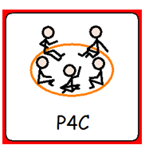
Philosophy For Children (P4C)
As philosophers, we will think and ask juicy questions about the big wide world. Listen to other people’s ideas and sometimes change our own opinions.

Our 5Rs: Learning to Learn
Throughout Year 2, we will continue to develop our independence, robustness when faced with learning challenge and the motivation to try hard. These are key attributes which will help us to learn and be successful.

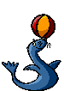
Reflective Resourceful Resilient Risk taking Reciprocal



