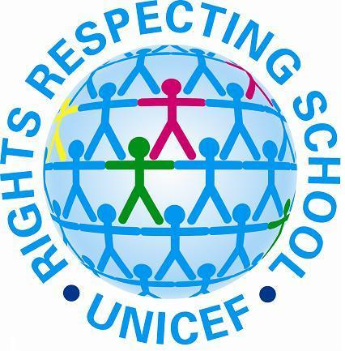
At Dobcroft Infant School we are on a journey towards becoming a Rights and Respecting school

As a school we are working towards the Unicef Rights Respecting School Award. We have recently updated our school vision and our school values. This was done in consultation with staff, governors, parents and most importantly the children.
UNICEF's RRSA initiative helps schools to use the United Nations Convention on the Rights of the Child to establish a Value's framework that underpins the curriculum and ethos of the school. Working on this framework has a positive effect on relationships, teaching approaches, attitudes and behaviour of everyone involved - adults and children! Other schools have reported that this work can:-
- Support and enhance children’s moral development
- Improve behaviour and relationships - children understanding both their rights and also their responsibilities
- Develops positive attitudes towards diversity and reduces prejudice
- Helps children understand their responsibility as a global citizens
- Results in overall whole school improvement in learning
- Enhanced job satisfaction for teachers
Have a look with your child at the posters which shows what their rights are.

This September we are focusing on the following articles:
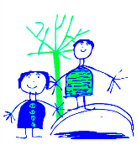
Dobcroft Infant School September 2016
Enjoy learning | Try our best | Make good choices | Respect each other & our surroundings | Work together | Celebrate our successes
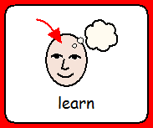 | 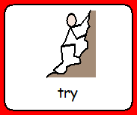 | 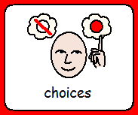 | 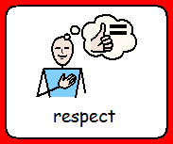 | 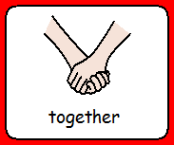 | 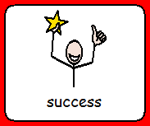

We are working towards becoming a level 1 Rights Respecting School.
This term we are learning about the following rights:
- All children have rights no matter what. Article 2

- You have a right to say what you think should happen and be listened to. Article 12

- You have a right to follow your own religion. Article 14

- You should be looked after and kept safe. Article 20

- You have a right to good food and water and see a doctor if you get ill. Article 24
