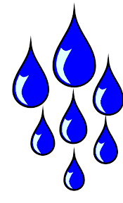
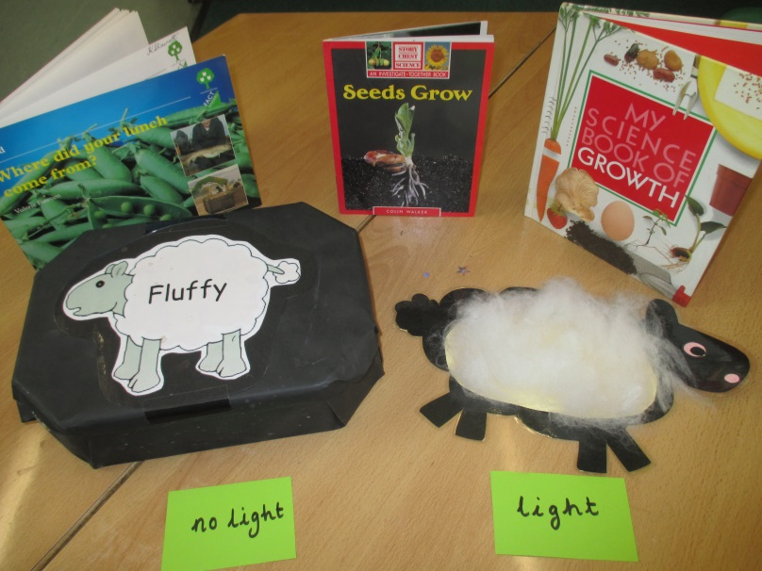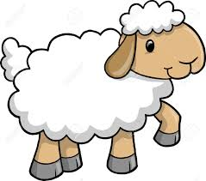
We set up an experiment with two sets of seeds:
We gave the first set water and light, and we gave the
second set water but no light. We gave each set the same
amount or water each day and then observed the seeds at
hometime each day.

My Prediction:

What actually happened:

