26/4/21 Name
WALT – Recognise the numbers on a hundred square
WILF – Children who can guess my number by asking questions using the language more/ less/ greater/ fewer/ odd/ even
Children who can answer questions to reveal their number
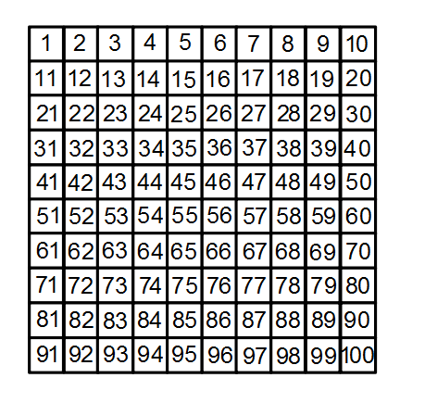

Comments made ..

