Pupil premium strategy statement – Dobcroft Infant
This statement details our school’s use of pupil premium (and recovery premium) funding to help improve the attainment of our disadvantaged pupils.
It outlines our pupil premium strategy, how we intend to spend the funding in this academic year and the outcomes for disadvantaged pupils last academic year.

School overview
Detail | Data
Number of pupils in school | 270 +26 place nursery
Proportion (%) of pupil premium eligible pupils | 3.3%
Academic year/years that our current pupil premium strategy plan covers (3 year plans are recommended) | 2022-25
Date this statement was published | Dec 2022
Date on which it will be reviewed | December 2023
Statement authorised by | Cathy Rowland
Pupil premium lead | Cathy Rowland/Zoe Singh
Governor / Trustee lead | Amie Clifford

Funding overview
Detail | Amount
Pupil premium funding allocation this academic year | £19,335
Recovery premium funding allocation this academic year | £ £2000
Pupil premium (and recovery premium*) funding carried forward from previous years (enter £0 if not applicable)  *Recovery premium received in academic year 2021 to 2022 can be carried forward to academic year 2022 to 2023. Recovery premium received in academic year 2022 to 2023 cannot be carried forward to 2023 to 2024. | £0
Total budget for this academic year  If your school is an academy in a trust that pools this funding, state the amount available to your school this academic year | £21,335

Part A: Pupil premium strategy plan

Statement of intent
- At Dobcroft Infant School we understand that each child is an individual and as such has completely different needs both educationally and personally. Some of the pupils for whom the Pupil Premium provides support for are working below the level of their peers, some are working significantly below their peers, and the school has identified the appropriate level of support and intervention, we have high expectations for all children, and we have great levels of challenge for all our pupils at all their levels. Our focus is for children to know more and remember more through effective intervention. Through support/identified outcomes we will do everything we can to help diminish the difference between pupils with PP, and those without, to enable them to be successful in the next stage of their education and beyond.
- In some cases,this support may be through time spent in the Butterfly room, receiving one to one intervention based on their specific learning needs or gaps in knowledge. We as a school, also understand that there may also be other social, emotional or psychological, barriers to learning as a result of the experiences in their lives and we are working with external professionals to ensure that we address them appropriately. Our aim is to ensure that all pupil premium children receive additional support and we will fund additional opportunities for such pupils.
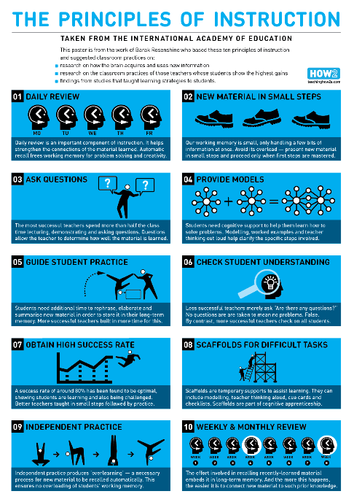
- Our current strategy involves identifying the individual child’s challenges or needs (we have very limited numbers of disadvantaged children who qualify for pp) then working with the class teacher to decide which is the best intervention. We use Rosenshine’s principles of instruction as a baseline for all that we do. Strategically, Roshensine was chosen because it was felt it would have the biggest impact on the children’s learning, knowing more and remembering more. Our staff have been using Rosenshin’s principles in the classroom for the past year and have put the principles of instruction into all interventions – Daily review, new materials in small steps, ask lots of questions, provide models (in many different forms) give time to practice and then check understanding (this is very important). Scaffold the task appropriately – know your student and know how they need to learn. Once this has been established, give the student time for independent practice. Finally – review.

Challenges
This details the key challenges to achievement that we have identified among our disadvantaged pupils.
Challenge number | Detail of challenge
1 | Assessments, observations, and discussions with pupils suggest disadvantaged pupils generally have greater difficulties with phonics than their peers. This negatively impacts their development as readers.
2 | Our assessments, observations and discussions with pupils and families indicate that the education and wellbeing of many of our disadvantaged pupils continues to be affected by the impact of the partial school closures during the COVID-19 pandemic, and to a greater extent than for other pupils. These findings are supported by national studies. This has resulted in significant knowledge gaps leading to pupils falling further behind age-related expectations, in reading, writing and maths.
3 | Our assessments, observations and discussions with pupils and families have identified social and emotional issues for many pupils. These challenges particularly affect disadvantaged pupils, including their attainment.

Intended outcomes
This explains the outcomes we are aiming for by the end of our current strategy plan, and how we will measure whether they have been achieved.
Intended outcome | Success criteria
Improve well being of children | Improving trend of confidence and metacognition skills in children in receipt of PP
Improved phonic attainment among disadvantaged pupils. | EYFS / KS1 outcomes and internal school data show diminishing the difference between pupils who are in receipt of PP and those that are not in phonics
Improved reading attainment among disadvantaged pupils. | EYFS / KS1 outcomes and internal school data show diminishing the difference between pupils who are in receipt of PP and those that are not in reading
Improved writing attainment among disadvantaged pupils. | EYFS / KS1 outcomes and internal school data show diminishing the difference between pupils who are in receipt of PP and those that are not in writing
Improved maths attainment among disadvantaged pupils. | EYFS / KS1 outcomes and internal school data show diminishing the difference between pupils who are in receipt of PP and those that are not in maths

Activity in this academic year
This details how we intend to spend our pupil premium (and recovery premium) funding this academic year to address the challenges listed above.

Teaching (for example, CPD, recruitment and retention)
Budgeted cost: £1820.00
Activity | Evidence that supports this approach | Challenge number(s) addressed
RWI staff training  Increased time for English co-ordinator to support RWI and Phonics | Evidence and rationale behind approach  Research from the EEF regarding teaching of phonics:  Phonics approaches have been consistently found to be effective in supporting younger readers to master the basics of reading, with an average impact of an additional four months’  progress. Research suggests that phonics is particularly beneficial for younger learners (4-7 year olds) as they begin to read.  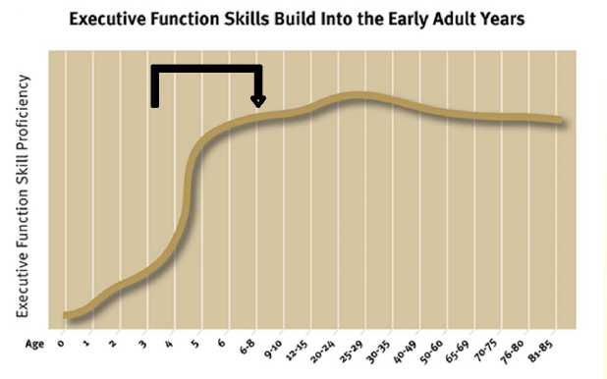  Teaching phonics is more effective on average than other approaches to early reading (such as whole language or alphabetic approaches), though it should be emphasised that  effective phonics techniques are usually embedded in a rich literacy environment for early readers and are only one part of a successful literacy strategy. We also embed strategies such as time to talk through school as well.  https://educationendowmentfoundation.org.uk/evidence-summaries/teaching-learning-toolkit/ this identifies the impact wider strategies have on educational attainment. | 1/2
Reading fluency training for English cordinator

Targeted academic support (for example, tutoring, one-to-one support, structured interventions)
Budgeted cost: £ 9249.00
Activity | Evidence that supports this approach | Challenge number(s) addressed
Reading interventions | We are again using the structure of Rosenshine to deliver our phonic and reading interventions.  We also ensure that we read for pleasure with all the children daily. When this is happening our TAs also target children to ensure that they are chatting with the children and talking to them about the books that they read to support the children’s love of reading. We were involved in a reading for pleasure project last year with the open university and we are keen to continue to develop this at DIS. We talk to children about the books they read making sure that staff are able to recommend current children’s book, are up to date with children’s reading books and they are aware of what books are winning awards. As written in “Teachers as Readers: Building Communities of Readers (2009), “the last decade of prescribed practice and the pressures of accountability are likely to continue to exert their influence upon teachers’ knowledge and use of literature for some considerable time to come” (Cremin; et al 2009). Teachers as readers: building communities of readers.) | 1/2
Writing Intervention | Again we use the principles of Rosenshine for our Writing interventions.  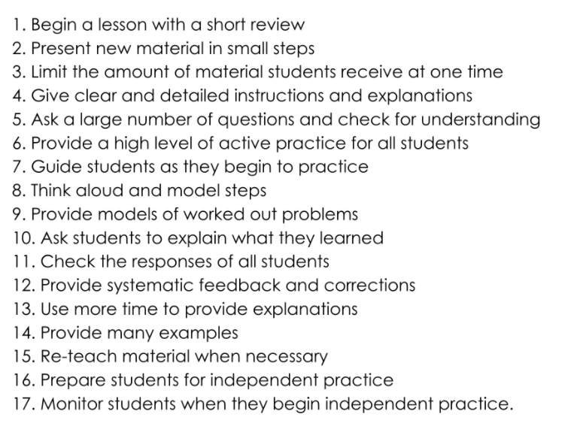  “Barak Rosenshine’s ‘Principles of Instruction’ has become increasingly influential in educational research and practice since its publication a decade ago.[1] Rosenshine (1930-2017) was formerly a professor of educational psychology in the College of Education at the University of Illinois. His research focused on learning instruction, teacher performance and student achievement. Much of his research focused on the distinctive features of effective teaching. His research has made a significant contribution to knowledge of the effectiveness of certain methods of ‘instruction’, which is typically defined as ‘the purposeful direction of the learning process’.[2] His principles of instruction are the culmination of his research into the effectiveness of methods of instruction.  Rosenshine’s ‘Principles’ provides a highly accessible bridge between educational research and classroom practice. The principles are research-based, extensively drawing upon research in education and cognitive science. Rosenshine expresses the principles succinctly and offers suggestions for the implementation of the principles in the classroom. He provides many examples of activities employed in the teaching practices of ‘master teachers’ – i.e., teachers whose students made the highest gains in achievement tests (p. 12).” Jonathan Beale, Researcher-in-Residence, CIRL | 2

Wider strategies (for example, related to attendance, behaviour, wellbeing)
Budgeted cost: £ 9178
Activity | Evidence that supports this approach | Challenge number(s) addressed
Butterfly Room Intervention | Our Butterfly room provides targeted support for our most vulnerable students. The room focuses on speech and language interventions as well as emotional literacy. It is so important for children to be able to manage their emotions and express themselves.  - “Theories of emotional and social intelligence have been around since the 1920s. In the 1970s, American developmental psychologist Howard Gardner’s multiple intelligence theory transformed thinking about the relationship between emotions and learning. In the mid-1990s, psychologist Daniel Goleman coined the phrase ‘emotional intelligence’, based on the work of influential researchers Peter Salovey and John D Mayer.  Daniel Goleman has suggested that there are five components critical to emotional intelligence. His book Working with Emotional Intelligence by Daniel Goleman (Bloomsbury) outlines these five domains of emotional intelligence as:  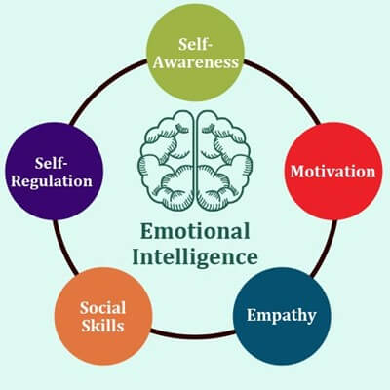  While the term emotional literacy is still relatively new, the importance of helping children to recognise, understand and express their emotions continues to gain traction. Experts believe that emotionally literate children are more able to:  - empathise with others  - build quality relationships  - develop independence and self-confidence and,  - attain more academically  Parents and teachers can help by modelling emotionally literate behaviours so that children can learn how to express their emotions in a healthy way.” https://childcarestudies.co.uk/2021/01/11/emotional-literacy-in-early-years/ In the butterfly room it is our top priority to support our children to be emotionally literate, we give our children strategies to support calming down and developing friendships. We work with both the autism team and speech and language therapist to ensure that we have the correct visuals and language rich environment to support this. | 3
Mental Health Support from Educational Mental health Practitioner  Cost of TA2 to support EMHP  £320.62 | We have a mental health practitioner who supports the school every Wednesday He uses the Healthy minds resources which have come from CAHMS directly.  He uses age appropriate emotional literacy support for different year group.  Autumn 1 - Year 1  Autumn 2 Year 2  Spring 1 Year 1  https://educationendowmentfoundation.org.uk/projects-and-evaluation/projects/developing-healthy-minds-in-teenagers | 3
uniform  £50.00 | Each child who is PP has an allowance of £50 to help with uniform costs.  https://www.tandfonline.com/doi/full/10.1080/19404476.2020.1759298 | 3
Personal well being materials  £350.00 | Each class has a turn around box to support emotional regulation. We also have a range of books to support different subjects such as bereavement. | 3
After school clubs  £1057.00 | Children in receipt of Pp can access 1 club per term  Children who frequently participate in after school activities are more likely to show greater levels of attention in class, be more engaged in school, and are less likely to develop an inclination for antisocial and or problem behaviour.” Physical and Mental health benefits of after school clubs, http://www.aspiretogreatness.co.uk/physical-mental-health-benefits-of-after-school-clubs | 3

Total budgeted cost: £ 22,025

Part B: Review of the previous academic year

Outcomes for disadvantaged pupils
We have analysed the performance of our school’s disadvantaged pupils during the 2021/22 academic year using EYFS/ key stage 1 performance data, phonics check results and our own internal assessments.
Schools are not required to publish their 2022 results as DfE is not publishing this data. This is because statutory assessments returned for the first time since 2019, without adaptations, after disruption caused by the pandemic.
DfE has shared our school’s 2022 performance data with us, to help us better understand the impact of the pandemic on our pupils and how this varies between different groups of pupils. COVID-19 had a significant impact on the education system and this disruption affected schools and pupils differently, and because of this, it is more difficult to interpret why the results are as they are using the data alone.
To help us gauge the performance of our disadvantaged pupils we compared our results to those for disadvantaged and non-disadvantaged pupils at a national and regional level (although these comparisons are to be considered with caution given the caveats stated above). We also looked at these comparisons using pre-pandemic scores for 2019, in order to assess how the performance of our disadvantaged pupils has changed during this period.
Despite the national picture our pupils at KS1 did well compared to National and the rest of their peers. We have such small numbers involved we don’t publish this but we have this analysis at school level, which we share with our link governor for PP. Our results trend reflect the fact that a much higher % of pupils who are in receipt of PP have identified Send needs . Currently 50% of children who are PP and 66% of children who are in receipt of PP+ compared to 13% as a school as a whole.

Externally provided programmes
Please include the names of any non-DfE programmes that you used your pupil premium (or recovery premium) to fund in the previous academic year.
Programme | Provider
RWI | Ruth Miskin

Service pupil premium funding (optional)
For schools that receive this funding, you may wish to provide the following information: How our service pupil premium allocation was spent last academic year
£0
The impact of that spending on service pupil premium eligible pupils
N/A

Further information (optional)
Additional links for further information:
https://www.timrasinski.com/presentations/article_why_fluency_shd_be_hot__rt_may_2012.pdf

https://www.psychologytoday.com/gb/blog/reading-minds/201701/the-music-reading-aloud

https://educationendowmentfoundation.org.uk/education-evidence/guidance-reports/literacy-ks-1

