Mrs Shepherd’s
Cooking Challenge

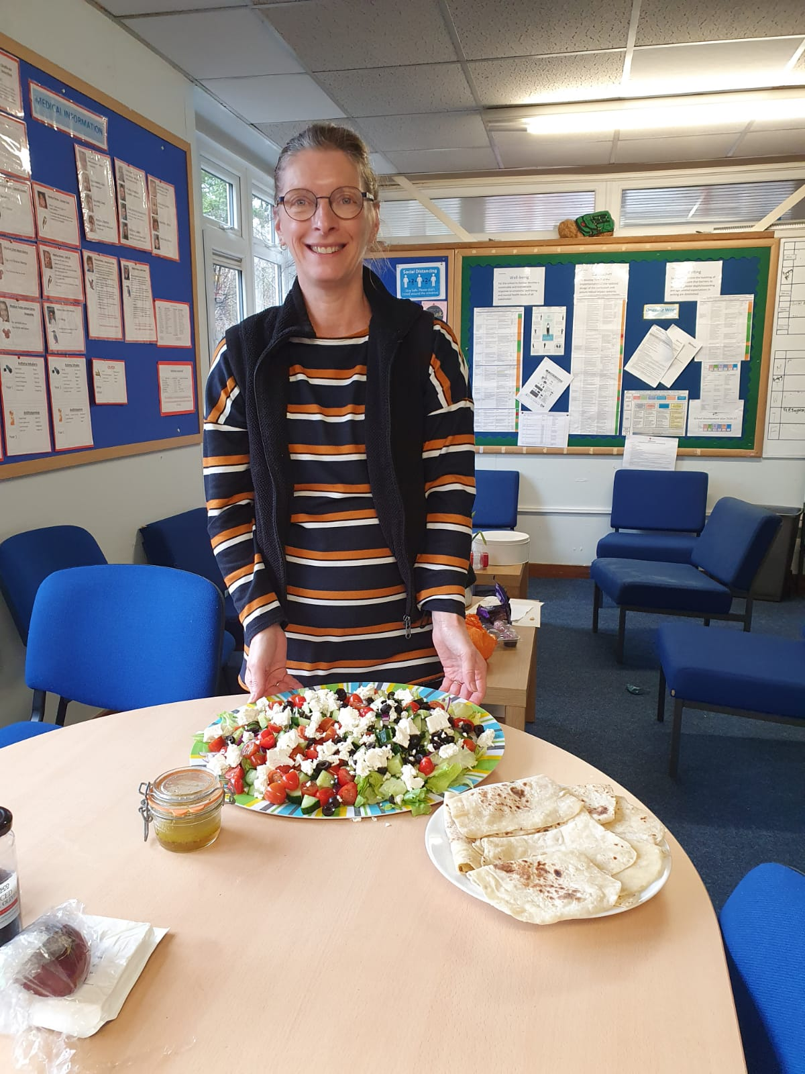

This week the challenge will be easy flatbread & Greek salad. If you do make the flatbread & salad please email pictures to enquiries@dobcroft-inf.sheffield.sch.uk. If you didn’t mind us putting the pictures on Twitter/school website then please let us know in the email. Leeeeet’s get cooking!

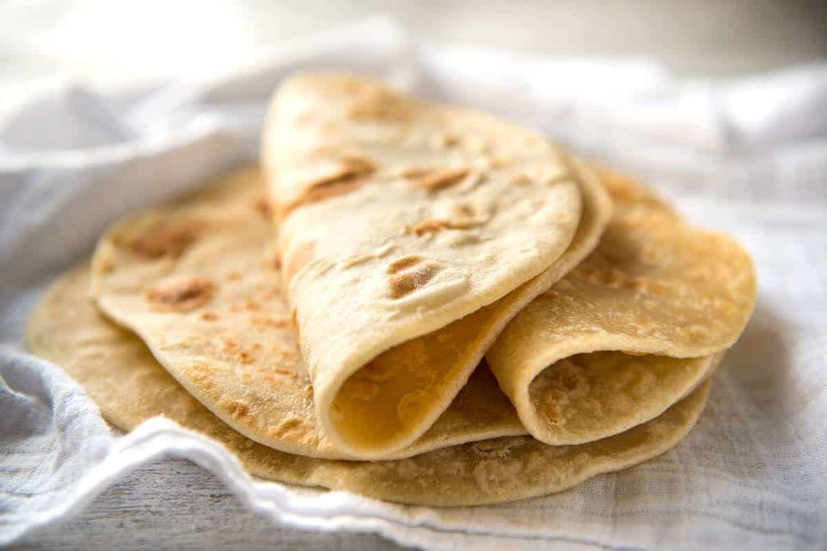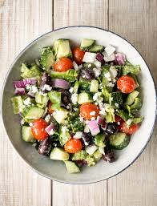

https://www.recipetineats.com/easy-soft-flatbread-yeast/

https://www.delish.com/cooking/recipe-ideas/recipes/a54226/best-greek-salad-recipe/

