Mrs Shepherd’s
Cooking Challenge

This week the challenge will be lemon drizzle cake. If you do make the cake please email pictures to enquiries@dobcroft-inf.sheffield.sch.uk. If you didn’t mind us putting the pictures on Twitter/school website then please let us know in the email. Leeeeet’s get cooking!

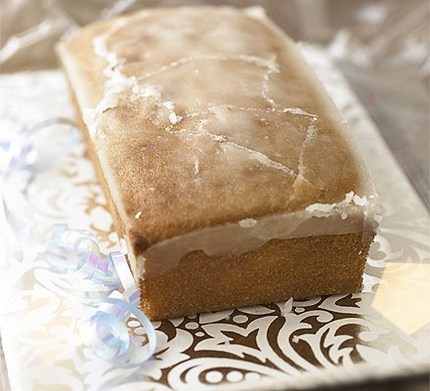

https://www.bbcgoodfood.com/recipes/lemon-drizzle-cake

