Problem Solving - Find the Difference
Place the numbers 1 to 6 in the circles so that each number is the difference between the two numbers just below it. Example: 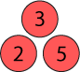 5−2=3

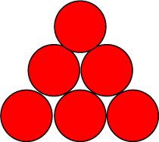

1 | 2 | 3 | 4 | 5 | 6

